NKTriF - A multimodal stable fusion approach for fine-grained stock movement prediction
Tieu Thanh Mai Anh 1^{a🖂}, Nguyen Viet Khoa 2ª, Ngo Tan Phong 3ª, Le Hung Phuc 4ª, Tran Vu Ha My 5ª
ªKhoa Thương mại điện tử, Trường Đại học Kinh tế - Đại học Đà Nẵng

ABSTRACT
Multimodal stock movement prediction faces two critical challenges: the temporal sparsity of financial news and cross-modal semantic conflicts among heterogeneous market signals. Without explicit regulation, conventional fusion approaches amplify input noise and degrade forecasting performance.
To address these limitations, this study proposes a deep learning architecture, named NKTriF (News-Knowledge Tri-modal Fusion), for fine-grained stock movement prediction utilizing three complementary modalities: historical price series, financial news, and macroeconomic indices. First, a structured extraction pipeline is introduced to compress raw financial news into compact entity-relation-object triples that capture high-density financial signals and target-stock sentiment. Second, a sequential two-stage Gated Cross-Attention Fusion module is designed to map complex cross-modal dependencies into an interaction-aware representation. By combining cross-attention with a price-conditioned gating mechanism, this module adaptively regulates auxiliary signal intake under sparse or conflicting data conditions.
Evaluation is conducted using a dataset of eight S&P 500 constituents spanning 869 valid trading sessions from January 2022 to June 2025. NKTriF achieves an accuracy (ACC) of 0.4324 and a Matthews Correlation Coefficient (MCC) of 0.1394, exceeding current leading methods and outperforming the strongest baseline by 1.3% in accuracy and 7.2% in MCC. Ablation studies confirm that each auxiliary modality provides incremental predictive power without degrading model performance due to cross-modal semantic conflicts. Practically, this work mitigates false trading signals during low-conviction market states, thereby enhancing capital preservation for quantitative trading strategies.
Keywords: stock movement prediction; multimodal fusion; gated cross-attention; financial knowledge extraction

Introduction
Short-horizon stock movement forecasting fundamentally depends on the rapid aggregation of heterogeneous market information. However, the signals driving next-session price dynamics arrive through fundamentally incompatible channels: historical price series encode market momentum and mean-reversion patterns; financial news carries high-impact, event-driven information regarding corporate developments and investor sentiment; and macroeconomic indices reflect system-level regimes that constrain equity valuations across sectors. While each information stream provides unique predictive insights, they operate at distinct temporal resolutions and carry disparate noise profiles. Consequently, the primary challenge in multimodal financial forecasting is not data availability, but rather structural incompatibility. Models must extract complementary predictive content from these heterogeneous sources without allowing differences in update frequency, reliability, and semantic scope to corrupt the unified representation.
The first practical obstacle is the temporal sparsity of financial news. Unlike historical price series that are continuously recorded each trading session without exception, news articles cluster around discrete corporate events, leaving numerous sessions without relevant coverage for a given stock. This induces a severe information density asymmetry across observations that multimodal frameworks must explicitly address (Baltrusaitis et al., 2019). Current models often fail to distinguish between the total absence of news and the presence of neutral text, treating uninformative zero-vectors as standard inputs during attention computation. Consequently, the softmax operation assigns non-zero weights to these empty positions, allowing uninformative features to pollute the fused output and degrade prediction accuracy during news-absent sessions (Zong et al., 2025).
A second, less-discussed challenge is cross-modal semantic conflict, as heterogeneous market signals rarely reflect identical states simultaneously. For instance, asset prices frequently move in anticipation of events before they are reported in the media, aligning with Tetlock's (2007) finding that news coverage often lags behind price dynamics. Conversely, system-level macroeconomic indices can temporarily diverge from the idiosyncratic movements of individual equities. When fused without accounting for these inherent lags and structural discrepancies, models receive contradictory directional signals at equal weight (Zong et al., 2025). Traditional symmetric fusion strategies, such as feature concatenation, bilinear pooling, or symmetric co-attention, treat all modalities equally by design (Baltrusaitis et al., 2019), providing no principled mechanism to resolve semantic conflicts. This leaves the fused representation highly sensitive to the noisiest input channel rather than anchored to the most reliable one, leading to unstable and poorly generalizing predictions.
Prior literature is further constrained by two methodological limitations. First, most text-based forecasting models encode financial articles as holistic sentence or document embeddings, failing to isolate stock-specific relevance. A single article often conflates broad market commentary with asset-specific events; pooling the entire text dilutes critical predictive signals with surrounding linguistic noise (Hu et al., 2018; Dolphin et al., 2024). Second, the prevailing task formulation in stock prediction is binary, classifying sessions purely as upward or downward moves, discarding the flat state where market forces are balanced (Soun et al., 2022; Zong et al., 2025). This artificial simplification introduces systematic label noise, significantly reducing the model's practical utility for active portfolio management.
To address these four limitations, this study proposes the NKTriF (News-Knowledge Tri-modal Fusion) approach, a deep learning architecture designed for fine-grained, three-class stock movement prediction. This study operates on three distinct information sources: historical price series, financial news, and macroeconomic indices. To overcome raw text dilution, a structured extraction pipeline is implemented to distill raw financial news into compact entity-relation-object triples via an LLM with few-shot prompting, isolating explicit financial signals and stock-specific sentiment before semantic encoding with FinBERT. Subsequently, a sequential two-stage Gated Cross-Attention Fusion module integrates the encoded representations to map complex cross-modal dependencies into an interaction-aware representation. By employing a price-conditioned gating mechanism, the module designates the historical price series as the primary anchor modality to adaptively regulate auxiliary news and macroeconomic inputs, suppressing conflicting signals without requiring explicit noise labels. Finally, prediction performance is evaluated using both Accuracy (ACC) and the Matthews Correlation Coefficient (MCC). MCC is utilized as the primary metric due to its sensitivity to all three movement classes, ensuring an accurate assessment of the flat category that standard accuracy underweights.
The remainder of this paper is organized as follows. Section 2 reviews related work on sequential price modeling, event-driven text approaches, and multimodal fusion strategies. Section 3 presents the NKTriF architecture. Section 4 describes the experimental setup. Section 5 reports results and ablation analyses. Section 6 discusses findings, states limitations, and concludes.

Literature review

Price-based sequential models
The earliest quantitative approaches to stock price forecasting treat the problem as a univariate time series task. They extract predictive information exclusively from the historical price record. Box and Jenkins (1976) propose the ARIMA framework, which captures autocorrelation in return sequences to generate one‑step‑ahead forecasts. Engle (1982) introduces the ARCH model, and Bollerslev (1986) generalises it to GARCH, enabling conditional variance modelling and representing volatility clustering. Cont (2001) documents volatility clustering as a persistent empirical regularity in financial time series. Both model families remain important reference points. However, they share a fundamental limitation. They are univariate and linear by construction. They operate solely on price history without any mechanism to incorporate exogenous information. Consequently, they cannot respond to unexpected market‑moving events until those events are already reflected in the price record.
The development of deep learning brings architectures that can model nonlinear temporal dependencies without assuming a fixed functional form. Hochreiter and Schmidhuber (1997) propose the Long Short‑Term Memory network, which becomes the standard architecture for long‑range sequential modelling in finance. Its three‑gate memory cell (input, forget, and output) preserves gradients through a constant error carousel, resolving the vanishing‑gradient problem identified by Bengio, Simard, and Frasconi (1994) as the primary obstacle for recurrent networks on long sequences. Greff et al. (2017) confirm through large‑scale ablation experiments that all three gates contribute meaningfully to LSTM performance and cannot be simplified without cost. Feng et al. (2018) augment the basic LSTM architecture with temporal attention (ALSTM), computing a weighted average over hidden states across the observation window. This weighting emphasises the time steps that are most informative for the prediction target. Cho et al. (2014) propose the Gated Recurrent Unit as a two‑gate simplification of LSTM that achieves comparable performance at lower computational cost.
Vaswani et al. (2017) introduce the Transformer architecture, which departs from the recurrence paradigm entirely. It replaces sequential computation with self‑attention that directly computes pairwise relevance scores across all positions in the sequence:
$Attention(Q,K,V)=softmax\left(\frac{QK^{⊤}}{\sqrt{d_{k}}}\right)V$
The scaling factor $\sqrt{d_{k}}$ prevents the dot‑product scores from saturating the softmax and suppressing gradients. By maintaining constant‑length information paths between any two positions regardless of their temporal distance, the Transformer addresses the representation bottleneck that limits recurrent architectures on long‑horizon dependencies. When applied directly to price sequences, Transformer‑based models achieve competitive short‑horizon forecasting performance. Qin et al. (2017) extend the attention paradigm to the multivariate setting with their DA‑RNN, which uses a two‑stage design. An input attention mechanism selects which exogenous series to emphasise at each time step. A temporal attention mechanism then weights historical encoder states for the final prediction. Yoo et al. (2021) apply a multi‑level Transformer in DTML, modelling both temporal and cross‑variable dependencies simultaneously. Huynh et al. (2023) concatenate price and macroeconomic features before multi‑head attention in their ESTIMATE model.
Regardless of architectural sophistication, price‑only models share a structural blind spot. They cannot anticipate event‑driven price movements because the signal they use (historical prices) only contains information about events that have already been absorbed by the market. This limitation motivates the integration of text‑based event information as a complementary input modality.

Text-based and event-driven approaches
A parallel research tradition treats financial text as a primary source of predictive information. The premise is that news, earnings announcements, and filings contain event-driven signals that often precede price movements historical prices cannot anticipate. Using text data, especially when processed by large language models, has the potential to increase stock price prediction accuracy. However, the effectiveness of this approach depends critically on the quality of the resulting semantic representations. Researchers have therefore developed a progression of text representation methods over time, each addressing the limitations of its predecessors.
Early work relies on static word representations. Mikolov et al. (2013) introduce Word2Vec, which learns distributed representations by predicting a word from its surrounding context. These vectors capture lexical similarity and analogical structure, but they assign a single fixed representation to each word token regardless of the sentence in which it appears. Peters et al. (2018) address this limitation with ELMo, which derives context‑dependent embeddings from a bidirectional LSTM language model. This allows the same word to receive different representations depending on its usage context. Devlin et al. (2019) scale this approach with BERT, a bidirectional Transformer encoder pretrained on large corpora through masked token prediction and next‑sentence prediction. BERT produces general‑purpose contextual representations that can be fine‑tuned for downstream classification tasks. Reimers and Gurevych (2019) adapt BERT for high‑quality sentence‑level similarity search by training a siamese network on natural language inference data.
Domain adaptation proves consequential in the financial setting. Yang, Uy, and Huang (2020) fine‑tune BERT on a large corpus of financial text, including earnings call transcripts, analyst reports, and news articles. The resulting FinBERT representations capture the sentiment and factual content of financial language more accurately than general‑purpose BERT. Huang, Wang, and Yang (2023) demonstrate that FinBERT consistently outperforms standard BERT on financial classification tasks. The performance gap is largest for language that combines domain‑specific terminology with implicit event signalling. Wu et al. (2023) extend this direction with BloombergGPT, a generative large language model trained exclusively on financial corpora. BloombergGPT establishes the current upper bound for domain‑adapted text representation quality.
Beyond raw embedding quality, the granularity of text representation matters for forecasting applications. Ding et al. (2015) demonstrate that representing news as structured event triples (subject, action, object) extracts stronger predictive signals than bag‑of‑words or sentence‑level embeddings. The structured representation isolates the financially relevant event from the surrounding linguistic context. Tetlock (2007) provides empirical grounding for the short time horizon over which news influence propagates. Media coverage of market sentiment has measurable effects on next‑day price movements, with most of the impact dissipating within one to two trading sessions. Hu et al. (2018) confirm that financial news carries an exploitable predictive signal but characterise it as a high‑noise, heterogeneous source. Its quality varies substantially across publication type, article length, and proximity to earnings events.
The practical challenge of linking article content to specific equity tickers introduces an additional layer of difficulty. Dolphin et al. (2024) show that entity‑to‑ticker linking in financial news remains unresolved. A single article may simultaneously discuss a target company, its supply chain partners, and the broader policy environment in which it operates. This makes it difficult to determine which portions of the text carry information about the target stock’s near‑term price movement. Wang, Cohen, and Ma (2024) model news interactions and influence relationships across articles. They demonstrate that cross‑article information propagation improves forecasting performance beyond single‑article encoding. Wadhwa, Amir, and Wallace (2023) establish that large language model prompting achieves competitive performance on financial relation extraction without parameter updates, opening a practical path for structured knowledge extraction at scale.
Text‑only models, however, face a structural limitation that is symmetric to that of price‑only models. They lack the price context needed to determine whether an event has already been discounted by the market. Their performance is also sensitive to the news sparsity problem, which is the absence of relevant coverage on many trading sessions. This creates instability in training when text‑absent days are not handled distinctly from informative ones.

Multimodal fusion strategies
The convergence of price‑based and text‑based research traditions toward multimodal integration has prompted sustained work on fusion strategies. These strategies determine how representations from heterogeneous sources are combined into a unified prediction‑ready feature. Baltrusaitis, Ahuja, and Morency (2019) characterise multimodal learning as confronting two core challenges that all fusion methods must address. The first is representation heterogeneity arising from different data structures and semantic spaces across modalities. The second is data incompleteness arising from unequal availability and reliability of observations across sources.
The simplest approach to combining modality‑specific representations is feature concatenation before the prediction layer, treating the combined vector as a standard classification input. Xu and Cohen (2018) apply this strategy to price embeddings and tweet representations in their StockNet framework. Fukui et al. (2016) propose bilinear pooling as a more expressive alternative that models pairwise feature interactions. Lu et al. (2016) introduce co‑attention, in which two modalities mutually determine which components of each other to attend to. These approaches share a common structural assumption. All modalities are treated symmetrically, with equal status assigned to every source regardless of its reliability, completeness, or informativeness on a given observation. This symmetry assumption is particularly problematic for financial data, where price indicators are available and informative at every session while news may be entirely absent.
Building on the attention mechanism of Vaswani et al. (2017), cross‑attention uses the Query from one modality and the Key‑Value pair from another. This enables one source to selectively retrieve information from another based on learned similarity. Tsai et al. (2019) develop the Multimodal Transformer for unaligned multimodal language sequences. They demonstrate that cross‑attention achieves strong results when modalities play asymmetric roles and do not require explicit temporal alignment. Soun et al. (2022) apply cross‑projection between price and text representations at each time step in their SLOT framework, achieving improved performance over static concatenation. Standard cross‑attention, however, has no explicit mechanism to down‑weight unreliable or contradictory contributions from auxiliary modalities. The softmax normalisation ensures that every auxiliary position receives non‑zero attention weight, regardless of whether that position carries a conflicting or uninformative signal.
A third line of work addresses this limitation through gating mechanisms that modulate information flow based on a conditioning signal. Srivastava, Greff, and Schmidhuber (2015) demonstrate through Highway Networks that sigmoid gates learning the pass‑through rate of information stabilise training and improve gradient propagation in deep architectures. Dauphin et al. (2017) propose the Gated Linear Unit, in which one branch computes a candidate feature and a second branch computes a sigmoid gate. Their element‑wise product selects which components of the feature to pass forward. When combined with cross‑attention, gated mechanisms provide a principled basis for asymmetric fusion that concatenation and standard co‑attention lack. A gate conditioned on the primary modality representation can suppress auxiliary contributions at positions where the sources carry conflicting or low‑reliability signals, formalised as:
$H_{fused}=ϕ(H_{aux}) ⊙ σ(H_{primary}W_{g}+b_{g})$
Here, the primary modality acts as the conditioning context that controls how much auxiliary information is absorbed at each position. This design property is directly suited to financial forecasting, where price data is more structurally reliable than event‑driven news or system‑level macro indices. Zong et al. (2025) apply this principle in MSGCA, using gated cross‑attention across three modalities including price, text, and an industry relation graph for three‑class stock movement prediction on Chinese market data. They demonstrate that primary‑guided gated fusion improves both mean accuracy and variance stability relative to symmetric cross‑attention.
Despite this progress, existing gated fusion frameworks do not address the problem of news temporal sparsity at the encoding stage. Zero vectors representing news‑absent days are passed through the fusion module as ordinary inputs, and the gating mechanism must learn to suppress them without being explicitly informed that they represent missing data rather than genuine neutral signals. Separating the absence‑handling mechanism from the gating mechanism, as NKTriF does through explicit masking and dual quality gating, provides cleaner signal separation than relying on the gate alone.

Comparative Overview and Research Gaps
Table 1 summarises representative stock movement prediction methods across eight comparative dimensions. Models evaluated on high‑news‑coverage US large‑cap stocks operate under substantially different data conditions than models evaluated on Chinese market data. In China, news frequency, language structure, and regulatory disclosure patterns differ markedly. This factor limits the direct comparability of reported accuracy figures across studies.
Table 1. Comparison of representative stock movement prediction methods.
Method | Author (Year) | Input modalities | News representation | Fusion mechanism | ACC
 | 2-class
LSTM | Fischer & Krauss (2018) | Price only | - | Temporal gating | N/A
ALSTM | Hu et al. (2018) | Price only | - | Temporal attention | 0.4869 - 0.5254
DA-RNN | Qin et al. (2017) | Price + macro | - | Dual-stage attention | N/A
DTML | Yoo et al. (2021) | Price + macro | - | Multi-level Transformer | 0.5276 - 0.5744
ESTIMATE | Huynh et al. (2023) | Price + macro | - | Concat + MHA | N/A
StockNet | Xu & Cohen (2018) | Price + text | Raw word-level | VAE | 0.5235 - 0.5360
SLOT | Soun et al. (2022) | Price + text | Self-supervised FinBERT | Cross-attention | 0.5481 - 0.5872
 | 3-class
MSGCA | Zong et al. (2025) | Price + text + industry graph | Raw FinBERT | Gated cross-attention | 0.3861 - 0.4379

Research methodology

Framework overview
The architectural blueprint of the proposed News-Knowledge Tri-modal Fusion (NKTriF) model is structured as an end-to-end deep learning framework, organized into three distinct operational phases: the Encoding Layer, the Fusion Layer, and the Prediction Layer. As illustrated in Figure 1, the model maps heterogeneous input streams onto unified representations to perform fine-grained market direction forecasting.
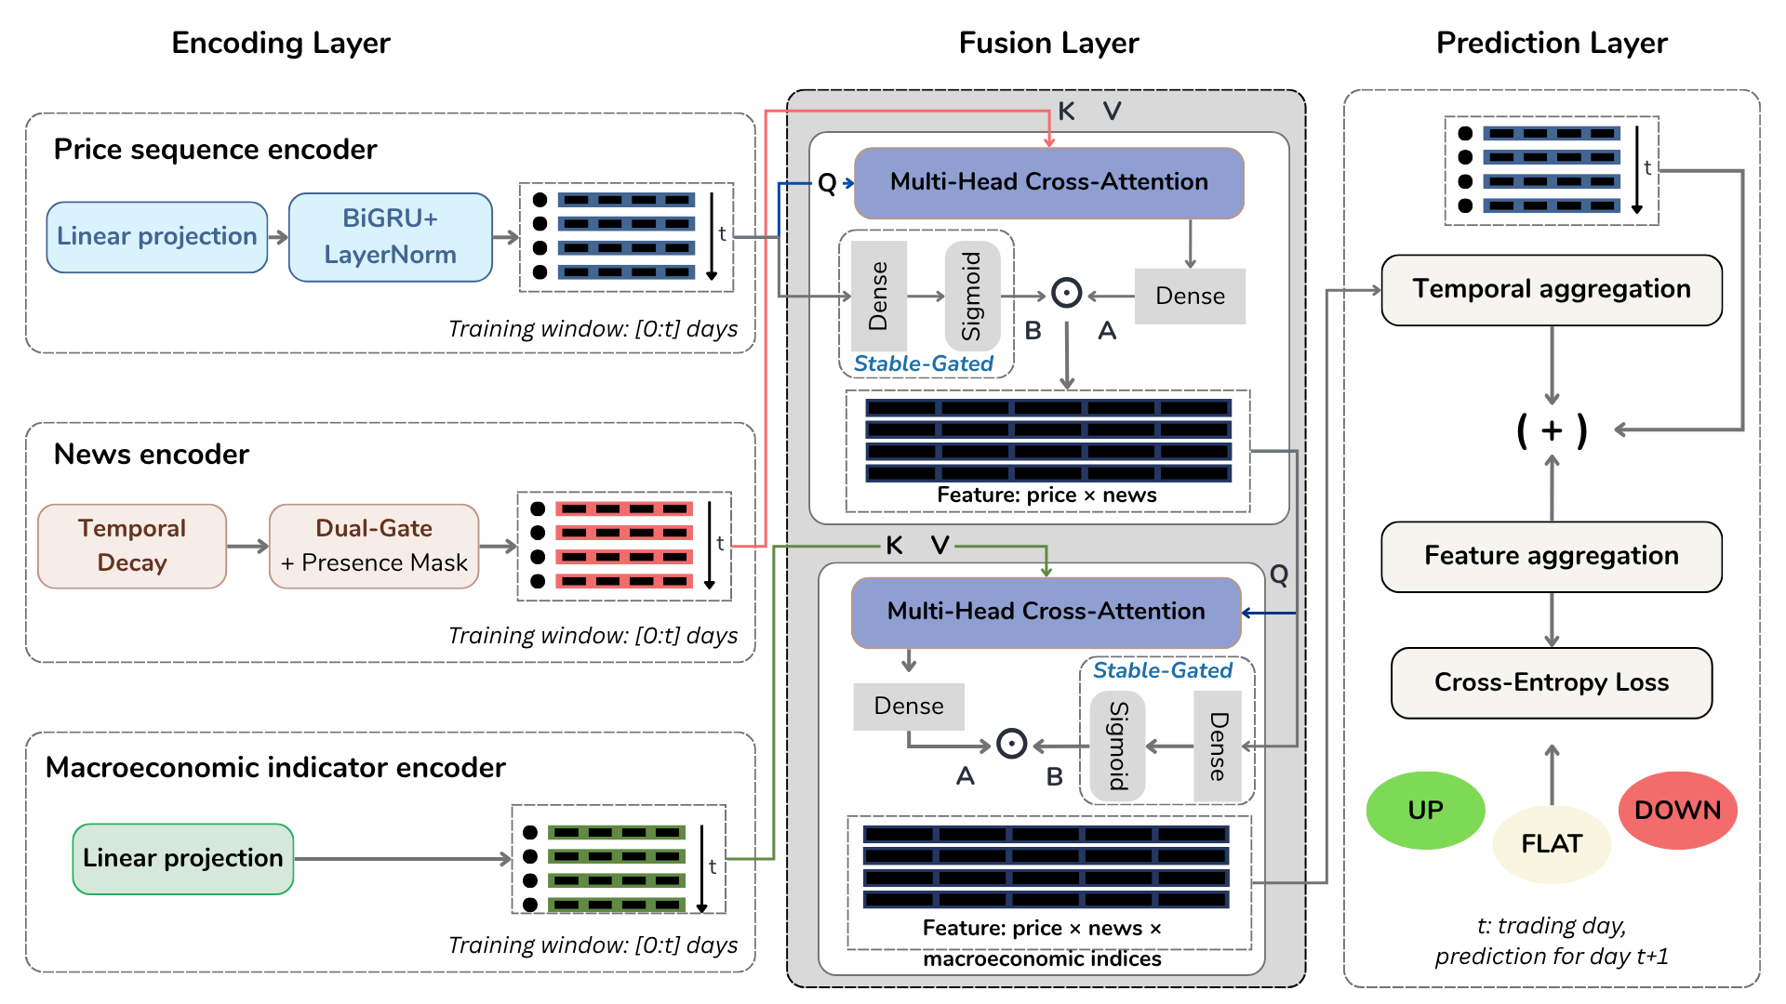Fig. 1. Framework of the proposed multi-modal NKTriF model.
- Encoding Layer: This layer establishes independent processing pipelines for each data modality within the training look-back window [0:t]. Raw inputs possess highly divergent dimensional structures and sampling rates. Dedicated encoders apply transformations, such as linear projections, temporal recurrent mechanisms (BiGRU), and decaying semantic filters, to project all three modalities into a shared latent space.
- Fusion Layer: Rather than employing symmetric concatenation, the encoded features are integrated through a sequential, cascading architecture. Stage 1 leverages a Multi-Head Cross-Attention block where the price indicator sequence generates the Queries (Q), selectively pulling event embeddings from the keys (K) and values (V) of the news branch. This output is filtered via a Stable-Gated block driven by a price-conditioned sigmoid gate. Stage 2 utilizes this intermediate price-news representation as a context anchor to cross-attend and ingest system-level features from the macroeconomic indicator encoder.
- Prediction Layer: The final joint feature tensor undergoes dual-stage dimensionality reduction. To safeguard the model from gradient degradation and feature attenuation throughout the fusion process, a parallel price stream is preserved and directly re-introduced to complement the temporally aggregated representations. Feature aggregation networks condense the combined tensors to map them into a three-class logit distribution corresponding to fine-grained market movements.
To systematically track the mathematical operations, tensor transformations, and variable dimensionalities moving across these sequential network layers, the foundational notations used throughout the remainder of this paper are formalized and defined in Table 2. These definitions encapsulate the structural dimensions of both the deep learning architecture and the processed multi-modal time-series windows.
Table 2. Notation used in NKTriF.
Symbol | Meaning
$B, T, d$ | Batch size; observation window length; latent embedding dimension
$d_{emb}, d_{mid},d_{tid},d_{q}$ | FinBERT dimension (768); intermediate news projection dim; ticker embedding dim; quality vector dim
$M,d_{k}$ | Number of attention heads; per-head dimension, dk=d/M
$s_{o},s_{h},s_{c}∈R^{T×1}$ | Open, high, and close price log-return sequences
$s_{n}∈R^{T×d_{emb}}$ | Daily FinBERT embedding of financial news
$s_{m}∈R^{T×5}$ | Macroeconomic index sequence
$q∈R^{T×d_{q}}$ | Daily knowledge quality vector
$v_{t}∈R^{d}$ | Encoder output for price, news, and macro modalities
$H_{i},H_{n},H_{m}∈R^{T×d}$ | Sequential encoder outputs for price, news, and macro modalities
$H_{i,n},H_{i,n,m}∈R^{B×T×d}$ | Fused representation after Stage 1 and Stage 2
$W, b$ | Learnable weight matrices and bias vectors
⊕,⊙, σ(⋅) | Feature-dimension concatenation; element-wise product; sigmoid function

Multimodal encoding
Each input modality has a distinct structure, update frequency, and noise profile that requires a dedicated encoder before joint processing. The shared objective of all three encoders is to project their respective inputs into the common representation space $R^{T×d}$, enabling the cross-attention mechanism in Section 3.3 to compute modality interactions on commensurate representations.

Price indicator encoder
The price encoder transforms three scalar indicator sequences - volatility-normalized log-returns of open, high, and close prices - into a sequential representation $H_{i}∈R^{T×d}$ through three steps designed to capture both directional trends and late-window reversal signals.
Step 1 - Independent projection and combination. Each indicator sequence is linearly projected to a $d$-dimensional space, and the three resulting embeddings are concatenated and re-projected:
$v_{c}=s_{c}W_{ic}+b_{ic},v_{o}=s_{o}W_{io}+b_{io},v_{h}=s_{h}W_{ih}+b_{ih}$ | (1)
$H_{comb}=(v_{c}⊕v_{o}⊕v_{h}) W_{i}+b_{i}∈R^{T×d}$ | (2)
where $W_{ic},W_{io},W_{ih}∈R^{1×d}$ and $W_{i}∈R^{3d×d}$. Projecting each indicator independently before combination allows the model to learn indicator-specific representations before computing their joint embedding.
Step 2 - BiGRU sequential encoding. $H_{comb}$is passed through a bidirectional GRU with hidden size $d/2$ per direction, producing output $H_{i}^{gru}∈R^{T×d}$:
$H_{i}^{gru}=BiGRU(H_{comb})$ | (3)
The forward direction accumulates trend information across the window; the backward direction captures reversal signals appearing near the most recent time step. This bidirectional design allows the encoder to represent both sustained momentum and late-window inflection points within the same $d$-dimensional output.
Step 3 - Residual connection and layer normalization.
$H_{i}=LayerNorm(H_{i}^{gru}+H_{comb})∈R^{T×d}$ | (4)
The residual connection preserves linear price information through the recurrent computation, preventing the loss of trend structure when the BiGRU gates partially suppress updates. Recurrent weight matrices are initialized orthogonally to stabilize gradient flow from the first training iteration; the update gate bias is initialized to 1.0 so that the gate starts in a pass-through state and learns selective forgetting progressively during training.

Financial news encoder
The news encoder takes FinBERT daily embeddings $s_{n}∈R^{T×d_{emb}}$ and a knowledge quality vector $q∈R^{T×d_{q}}$ as inputs, and produces $H_{n}∈R^{T×d}$through three stages. Days with no valid news triples retain a zero vector after encoding and are marked with a binary mask flag that suppresses their positions in the cross-attention computation of Section 3.3.
Stage 1 - Temporal decay weighting. News published closer to the forecast horizon carries stronger predictive relevance than older news within the same observation window. An exponential decay function formalizes this assumption:
$s_{n,t}^{decay}=s_{n,t}⋅exp⁡(-α⋅(T-t)),t=1,…,T$ | (5)
where $α>0$ is the decay coefficient. The exponential form is preferred over linear decay because it assigns near-zero weight to events older than a few sessions, consistent with Tetlock's (2007) evidence that news-driven price effects dissipate rapidly and are substantially incorporated within one to two trading days. Under this formulation, news at the final step $t=T$ receives unit weight, while news at $t=1$ receives weight $exp⁡(-α(T-1))$.
Stage 2 - Two-step dimensionality reduction. Direct projection from $d_{emb}=768$ to $d$compresses a high-dimensional space in a single step, risking the loss of fine-grained semantic distinctions. An intermediate projection through dimension $d_{mid}$ reduces this risk:
$H_{mid}=LayerNorm(GELU(s_{n}^{decay} W_{n1}+b_{n1}))∈R^{T×d_{mid}}$ | (6)
$H_{n}^{proj}=LayerNorm(GELU(H_{mid} W_{n2}+b_{n2}))∈R^{T×d}$ | (7)
where $W_{n1}∈R^{d_{emb}×d_{mid}}$ and $W_{n2}∈R^{d_{mid}×d}$. GELU activations with layer normalization at each step stabilize the compression across the two stages.
Stage 3 - Dual quality gating. Not all news embeddings that pass the quality filtering threshold carry equal predictive value. Two complementary gates regulate the contribution of each daily representation before it enters the fusion module.
The quality gate $g_{n}^{q}$ is conditioned on the knowledge quality vector $q$, which encodes the aggregate confidence and relevance scores of the triples extracted from that day's articles:
$g_{n}^{q}=σ(GELU(q W_{q1}+b_{q1}) W_{q2}+b_{q2})∈R^{T×1}$ | (8)
The feature gate $g_{n}^{f}$ is conditioned on the projected embedding itself, assessing the intrinsic informativeness of the representation independently of the quality metadata:
$g_{n}^{f}=σ(GELU(H_{n}^{proj} W_{f1}+b_{f1}) W_{f2}+b_{f2})∈R^{T×1}$ | (9)
The final news encoder output is the element-wise product of the projected representation and both gates:
$H_{n}=H_{n}^{proj}⊙g_{n}^{q}⊙g_{n}^{f}∈R^{T×d}$ | (10)
The quality gate suppresses representations from days where extracted triples have low confidence or low ticker relevance; the feature gate provides a complementary signal by down-weighting projected representations that are intrinsically uninformative regardless of their metadata scores. Together, the two gates ensure that only embeddings carrying both externally validated and internally coherent signals pass into the fusion module at meaningful magnitude.

Macroeconomic indicator encoder
The macro encoder maps five daily macroeconomic indices, VIX, the 10Y–2Y Treasury yield spread, the S&P 500 daily return, the US Dollar Index (DXY), and WTI crude oil price, to the shared latent space via a single linear projection:
$H_{m}=s_{m} W_{m}+b_{m}∈R^{T×d}$ | (11)
where $W_{m}∈R^{5×d}$. The intentional simplicity of this encoder reflects the role macroeconomic data plays in the architecture: it provides stable, system-level background context rather than event-specific directional signals. Architectural complexity, in the form of multiple nonlinear layers and recurrent processing, is concentrated in the fusion module where modality interactions are resolved, rather than in the encoder of the modality with the lowest noise and highest temporal completeness.
All five indices are z-scored using training-set statistics only and lagged by one trading day before encoding, ensuring that the model uses only information observable prior to the session being predicted.
After encoding, all three modalities occupy the shared space $R^{T×d}$. This is a necessary precondition for the cross-attention mechanism in Section 3.3, which computes dot-product similarity between modality representations and requires them to be commensurate in both dimension and scale. Projecting all three modalities to the same $d$absorbs the alignment cost into the encoder linear layers. This design keeps the overall parameter count tractable relative to alternatives that maintain modality-specific latent spaces and require separate alignment networks before fusion.
Table 3. Summary of encoder architectures.
Encoder | Input | Architecture | Output
Price | $R^{T×3}$ | Linear $×3$→ Concat ($3d→d$) → BiGRU($d$)  → Residual + LayerNorm | $H_{i}∈R^{T×d}$
News | $R^{T×d_{emb}}$ | Decay → Linear ($d_{emb}→d_{mid}$) → GELU + LN  → Linear ($d_{mid}→d$) → GELU + LN → Dual gate  ($g_{n}^{q}×g_{n}^{f}$) | $H_{n}∈R^{T×d}$
Macro | $R^{T×5}$ | Linear ($5→d$) | $H_{m}∈R^{T×d}$

Gated Cross-Attention Fusion

Design rationale
The design of the Gated Cross-Attention (GCA) fusion module rests on three architectural principles. First, historical price series serve as the primary anchor modality across all fusion stages because price data is the only input that is temporally complete and asset-specific at every trading session, whereas news is temporally sparse and macroeconomic indices reflect broad system-level conditions. Designating price as the conditioning context leverages the most structurally reliable signal to dynamically regulate the intake of noisier auxiliary sources. Second, the module explicitly decouples cross-modal feature interaction from signal selection by executing multi-head cross-attention and gated feature filtering sequentially, rather than conflating them within a single operational step. Third, a sequential cascading structure is preferred over parallel fusion to exploit the functional asymmetry between auxiliary modalities. Early integration allows short-horizon, event-driven news signals to enrich the price representation in Stage 1, creating a contextually richer intermediate anchor that is better suited to capture interactions with slower-moving, regime-level macroeconomic indicators in Stage 2.

Cross-attention mechanism
A single GCA block takes two sequence representations as input: the primary modality $H_{primary}∈R^{B×T×d}$ and the auxiliary modality $H_{aux}∈R^{B×T×d}$, and then produces an unstable fused output $H_{unstable}∈R^{B×T×d}$ through multi-head cross-attention.
For each head $m ∈ \{1,…,M\}$, the query is derived from the primary modality and the key-value pair from the auxiliary:
$Q_{m}=H_{primary} W_{m}^{Q},K_{m}=H_{aux} W_{m}^{K},V_{m}=H_{aux} W_{m}^{V}$ | (12)
${head}_{m}=softmax \left(\frac{Q_{m}K_{m}^{⊤}}{\sqrt{d_{k}}}\right)V_{m}$ | (13)
$H_{unstable}=({head}_{1}⊕⋯⊕{head}_{M}) W^{O}∈R^{B×T×d}$ | (14)
where $W_{m}^{Q},W_{m}^{K},W_{m}^{V}∈R^{d×d_{k}}$ and $W^{O}∈R^{Md_{k}×d}$. The scaling factor $\sqrt{d_{k}}$ prevents the dot-product scores from entering the saturation region of the softmax, preserving meaningful gradient flow during training.
When the auxiliary modality is news, positions corresponding to news-absent days are masked before softmax is applied, setting their logits to $-∞$ and forcing their attention weights to zero. This prevents zero-vector news embeddings from receiving non-zero attention and influencing the fused output at time steps where the news channel carries no information.

Gated stable feature selection
The cross-attended output $H_{unstable}$ captures interactions between the two modalities but may incorporate conflicting or noisy auxiliary signals that degrade representation quality. The gated selection step uses the primary modality as a conditioning signal to regulate how much of the cross-attended information is retained.
A linear transformation of $H_{unstable}$ produces the candidate feature $H_{a}$; a sigmoid gate conditioned on the primary modality produces the selection weight $H_{b}$:
$H_{a}=H_{unstable} W_{a}+b_{a}$ | (15)
$H_{b}=σ(H_{primary} W_{b}+b_{b})$ | (16)
$H_{gated}=H_{a}⊙H_{b}$ | (17)
The gate $H_{b}$ learns to condition on the price context at each time step, how strongly to weigh the cross-modal information before it enters the fused representation. At positions where the auxiliary signal is consistent with the primary, the gate remains open; at positions where they conflict, the gate suppresses the auxiliary contribution - without requiring explicit noise labels during training.
A residual connection adds the gated output to the primary modality representation, followed by layer normalization:
$H_{output}=LayerNorm(H_{primary}+H_{gated}) ∈ R^{B×T×d}$ | (18)
The residual connection guarantees a direct gradient path through the primary modality during backpropagation, preserving price information when the gate suppresses auxiliary contributions. The gate bias $b_{b}$ is initialized to 1.0, so the gate starts in a near-open state and learns selective suppression progressively as training proceeds.
Denoting the full procedure from Equations (13)–(19) as $GCA(H_{primary}, H_{aux})$, the two sequential fusion stages are:
$H_{i,n}=GCA(H_{i},H_{n})∈R^{B×T×d}$ | (19)
$H_{i,n,m}=GCA(H_{i,n},H_{m})∈R^{B×T×d}$ | (20)
In Stage 1, the raw price representation $H_{i}$ anchors the fusion with news. In Stage 2, the news-enriched intermediate representation $H_{i,n}$- which carries both price dynamics and selectively retained event signals - anchors the fusion with macroeconomic context. This cascading structure allows each stage to operate with a progressively richer primary signal.

Movement prediction module
The prediction module compresses $H_{i,n,m}∈R^{B×T×d}$to a three-dimensional output probability vector through two sequential dimension-reduction steps: temporal aggregation followed by feature aggregation.

Time-dimension aggregation
Multi-stage fusion can attenuate the original price signal through successive nonlinear transformations. To preserve direct access to this signal at the prediction stage, the architecture maintains a parallel price stream alongside the fused representation.
Before aggregation, the fused representation is combined with the ticker identity embedding $H_{t}^{seq}∈R^{T×d}$ - the time-expanded version of $v_{t}$- to condition the output on the target stock:
$H_{fused}=GELU(LayerNorm([H_{i,n,m}⊕H_{t}^{seq}] W_{fused}+b_{fused})) ∈{ R}^{B×T×d}$ | (21)
The original price stream is kept unchanged:
$H_{orig}=H_{i}∈R^{B×T×d}$ | (22)
A three-layer MLP network ${MLP}_{t}$ - with layer sizes reducing the time dimension as $T → T/2 → T/4 → 1$ is applied independently to both streams, collapsing the temporal dimension while preserving the full feature dimension:
$h_{fused}={MLP}_{t}(H_{fused})∈R^{B×d}$ | (23)
$h_{orig}={MLP}_{t}(H_{orig})∈R^{B×d}$ | (24)
The parallel stream ensures that if the fusion module introduces noise at any step, the predictor retains a direct, unfused price signal as an alternative basis for the final classification.

Feature-dimension aggregation and prediction output
The two temporally aggregated representations are concatenated
$h=h_{fused}⊕h_{orig}∈R^{B×2d}$ | (25)
A second MLP network ${MLP}_{f}$ with layer sizes $2d → d → d/2 → 3$ projects $h$to the three-class logit space:
$p={MLP}_{f}(h)∈R^{B×3},\hat{y}=arg⁡{max⁡}_{c} p_{c}$ | (26)
No activation function is applied at the final layer; the softmax is computed implicitly within the cross-entropy loss during training.

Loss function
The rolling-percentile labeling mechanism (described in Section 4.1.2) produces near-equal class proportions - approximately 33% up, 33% flat, and 33% down per stock - across the experimental dataset. This near-balanced distribution removes the primary motivation for class-weighted loss, which is intended to counteract learning bias when a minority class is severely underrepresented. Standard cross-entropy is therefore selected as the training objective, ensuring a fair, comparator-consistent basis for evaluating the contribution of architectural choices rather than loss function design.
The loss over a batch of $N$ samples is:
$L=-\frac{1}{N}\sum_{n=1}^{N}{}\sum_{c=1}^{3}{}l_{n,c}⋅log⁡\left(\frac{exp⁡(p_{n,c})}{\sum_{j=1}^{3}{}exp⁡(p_{n,j})}\right)$ | (27)
where $p_{n,c}$ is the logit for class $c$of sample $n$, and $l_{n,c} ∈ \{0,1\}$ is the one-hot ground-truth label. All parameters are optimized end-to-end via backpropagation using the AdamW optimizer.

Experiments

Dataset construction

Data scope
The experimental dataset comprises eight S&P 500 constituents selected to represent four distinct sectors: TSLA and AMZN (Consumer Discretionary); AAPL, MSFT, GOOGL, and META (Technology); BA (Industrials); and WMT (Consumer Staples). Data collection spans January 1, 2022, to June 23, 2025, a period chosen for its regime diversity. It encompasses the most aggressive monetary tightening cycle in four decades, the AI-driven equity rerating of 2023–2024, and elevated geopolitical risk episodes (Board of Governors of the Federal Reserve System, 2023; Krauskopf, 2023; International Monetary Fund, 2025). This variety subjects the model to materially different macro regimes within a single evaluation window, providing a stronger generalization test than a single-regime period would allow.
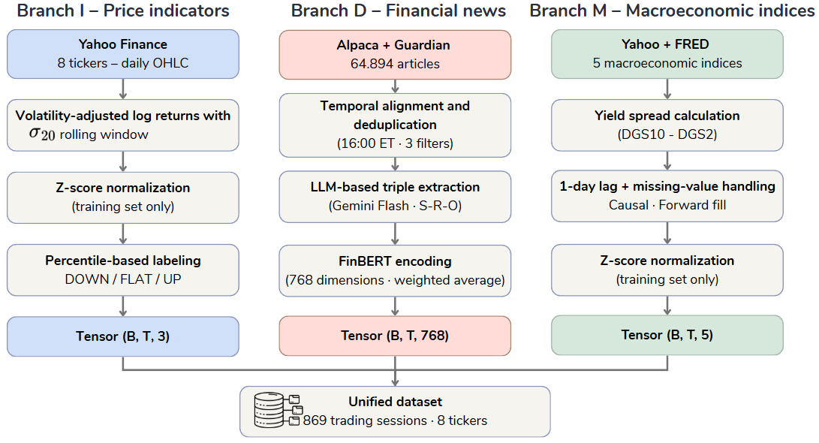
Fig. 2. The preprocessing and unified dataset construction workflow.
As illustrated in Fig. 2, the dataset construction pipeline operates across three independent branches that are subsequently synchronized to the unified trading calendar. The price branch (Section 4.1.2) applies volatility-normalized log-return transformation followed by z-score standardization. The news branch (Section 4.1.3) executes a six-step knowledge extraction pipeline (Table 5) that distills raw articles into FinBERT-encoded entity-relation-object triples. The macroeconomic branch (Section 4.1.4) applies one-day lag adjustment and z-score normalization to five system-level indices. All three branches are merged at the trading-day level before rolling-percentile label assignment (Section 4.1.5).
Three data branches including price, news, and macroeconomic indices are collected independently and synchronized to the trading calendar, yielding 869 valid trading sessions. After applying the T = 20 look-back window, 849 usable time steps are available, producing 6,792 samples across eight stocks.

Price data pipeline
Daily price data are retrieved from Yahoo Finance via the yfinance library. Three split- and dividend-adjusted price series are used as inputs: open, high, and close prices. Trading volume is excluded from the feature set.
For each price series P, the log-return at time step t is computed as:
$r_{t}=ln\left(\frac{P_{t}}{P_{t-1}}\right)$
The raw log-return is then scaled by the 20-day realized volatility to produce a volatility-adjusted return:
$\tilde{{r_{t}}_{}}=\frac{r_{t}}{max\left(σ_{20}, ε\right) }$
where $σ_{20}$ is the standard deviation of close-price log-returns over the preceding 20 trading sessions, and $ε=0.02$ serves as a minimum divisor for the first 20 sessions before a complete rolling window is available. Once the rolling computation is active, a numerical floor of ${10}^{-6}$ is applied to prevent instability during periods of near-zero realized volatility. This normalization allows each price series to adapt automatically to the prevailing market regime without manual threshold adjustments across structurally different periods.
The three normalized return series are subsequently z-scored using training-set mean and standard deviation only, with the same parameters applied consistently to the validation and test splits to prevent information leakage. The construction of the prediction target and the assignment of directional labels from these return series are described in Section 4.1.5.

News data pipeline
Financial news is collected from two complementary sources. The Alpaca News API provides articles tagged with stock ticker symbols via a paginated REST interface, enabling direct filtering to the eight target stocks without an additional entity-linking step. The Guardian is collected through web crawling with BeautifulSoup to supplement Alpaca with longer-form corporate analysis and industry commentary. Table 4 summarizes the technical characteristics and processing logic of each source.
Table 4. News data sources: technical specifications and processing rules.
Source | Method | Key characteristics | Source-specific processing
Alpaca News API | REST API (50 articles/call, paginated via next_page_token, auto-retry) | Ticker-tagged articles, structured JSON response | Strip HTML tags; filter symbols field to 8 target tickers
The Guardian | Web crawling (requests + BeautifulSoup, User-Agent header) | Long-form analysis and commentary | Extract date from datetime attribute; extract body from paragraph tags
Following collection, text from both sources is standardized into a uniform four-field schema: date, ticker, headline, and body. The combined corpus undergoes three sequential filtering rules: (i) records missing either body text or a valid publication date are discarded; (ii) duplicate entries identified by the (date, ticker, headline) tuple are removed; and (iii) articles published after 16:00 Eastern Time are rolled forward to the next valid trading session to mitigate look-ahead bias and enforce strict temporal causality.
This initial pre-processing yields 64,894 article-ticker assignments, where each (article, ticker) pair is counted independently. The corpus then undergoes two subsequent reduction stages. First, alignment with the 869 valid trading sessions and filtering for the eight target tickers reduces the sample to 59,967 assignments. Second, LLM extraction and quality filtering (Table 5, Steps 3–5) yield a final sample of 8,983 article-ticker pairs containing at least one validated financial triple, which proceed to FinBERT encoding.
Raw financial articles are converted to structured semantic representations through a six-step pipeline before entering the model. Table 5 summarizes each step.
Table 5. Knowledge extraction pipeline: steps, processing, and outputs.
Step | Processing | Primary output
1 | Submit article to Gemini 2.0 Flash via a three-tier prompt (system + few-shot examples + JSON-schema-constrained user instruction) | Entity-relation-object triples with confidence, price_impact_score ∈ [−1, +1], and relevance_to_ticker ∈ [0, 1]
2 | Classify article into one of four types: financial result (A), corporate action (B), regulatory/legal event (C), or commentary/opinion (D) | Article type label and expected triple count range
3 | Retain only triples with confidence ≥ 0.65 and relevance_to_ticker ≥ 0.50 | Quality-filtered triple set
4 | Exact and fuzzy semantic deduplication: normalize entity name variants (e.g., "Walmart", "Walmart Inc.", "WMT") to a canonical form; retain the highest confidence × relevance triple on conflict | Semantically deduplicated triple set
5 | Correct inverted REGULATES relations (where subject is COMP rather than ORG_REG); cap per-analyst-source triples at one price-target and one rating per company | Final validated triple set
6 | Convert each triple to a natural-language sentence; encode with ProsusAI/FinBERT (parameters frozen); aggregate to a daily vector by weighted average | 768-dimensional news vector per (date, ticker) pair
Steps 1–2 - Extraction. Each article is submitted to Gemini 2.0 Flash with a three-tier prompt comprising a system prompt that specifies the extraction schema (8 entity types, 14 relation types, 3 scoring dimensions), three few-shot examples covering article types A, C, and D, and a user prompt requiring JSON-schema-constrained output. The extracted units are subject-relation-object (S-R-O) triples, each annotated with a confidence score, a directional price impact score $p_{i}∈\left[-1,+1\right]$, and a relevance score ${rel}_{i}∈\left[0,1\right]$. The same prompt simultaneously classifies the article into one of four types, which governs the expected event density: financial results (A) typically yield four to seven triples, corporate actions (B) yield three to five, regulatory or legal events (C) yield two to four, and opinion or commentary pieces (D) yield zero to two, with the latter returning an empty set when no direct financial claim is present. Extraction temperature is set to 0.1 to balance output consistency with tolerance for linguistically ambiguous content.
Steps 3–5 - Filtering and cleaning. Quality filtering retains only triples with confidence at or above 0.65 and relevance at or above 0.50. Semantic deduplication then resolves cross-article references to the same financial event by normalizing entity name variants to a canonical form and retaining the highest-scoring triple when the same event is identified from multiple articles. Two supplementary validation rules are applied in sequence: inverted REGULATES relations, where a company appears as the regulating subject rather than a recognized regulatory body, are corrected by reversing the subject-object direction; per-analyst-firm contributions are capped at one price-target action and one rating action to prevent a single analyst report from dominating the daily signal.
Step 6 - FinBERT encoding and daily aggregation. Each validated triple is converted to a short declarative sentence using a standardized natural-language template, then encoded by ProsusAI/FinBERT with all parameters frozen throughout training. The 768-dimensional [CLS] token representation from the final hidden layer serves as the embedding for each triple. The daily news vector for each (date, ticker) pair is computed as the weighted average:
$e_{t,k}=\frac{\sum_{i}{}w_{i}v_{i}}{\sum_{i}{}w_{i}},w_{i}=∣p_{i}∣×{conf}_{i}×{rel}_{i}$
where $v_{i}$ is the FinBERT embedding of triple $i$, $p_{i}$ is price impact score, ${conf}_{i}$ is confidence, and ${rel}_{i}$ is the relevance to the target ticker. This weighting scheme assigns higher importance to triples that simultaneously carry high extractor confidence, clear directional price impact, and strong relevance to the target stock. Days with no valid triples receive a zero vector and are marked with a binary mask flag that suppresses their positions in the subsequent cross-attention computation.
Table 6. Descriptive statistics of raw news articles and extracted triples by ticker
Ticker | News count | Average tokens/news | Triplet count | Average tokens/triplet
TSLA | 2,655 | 468.6 | 5,506 | 5.6
AAPL | 1,424 | 522.9 | 2,616 | 5.5
AMZN | 1,197 | 582.5 | 2,293 | 5.2
MSFT | 1,064 | 489.0 | 2,087 | 5.0
GOOGL | 888 | 520.3 | 1,612 | 5.3
META | 867 | 571.6 | 1,681 | 5.6
BA | 543 | 561.8 | 1,105 | 5.8
WMT | 345 | 493.4 | 798 | 6.0
Figure 3 illustrates the structural properties of the extracted triple set across two dimensions: the distribution of triple count per article, and the breakdown of relation types, subject entity types, and object entity types across the full corpus.
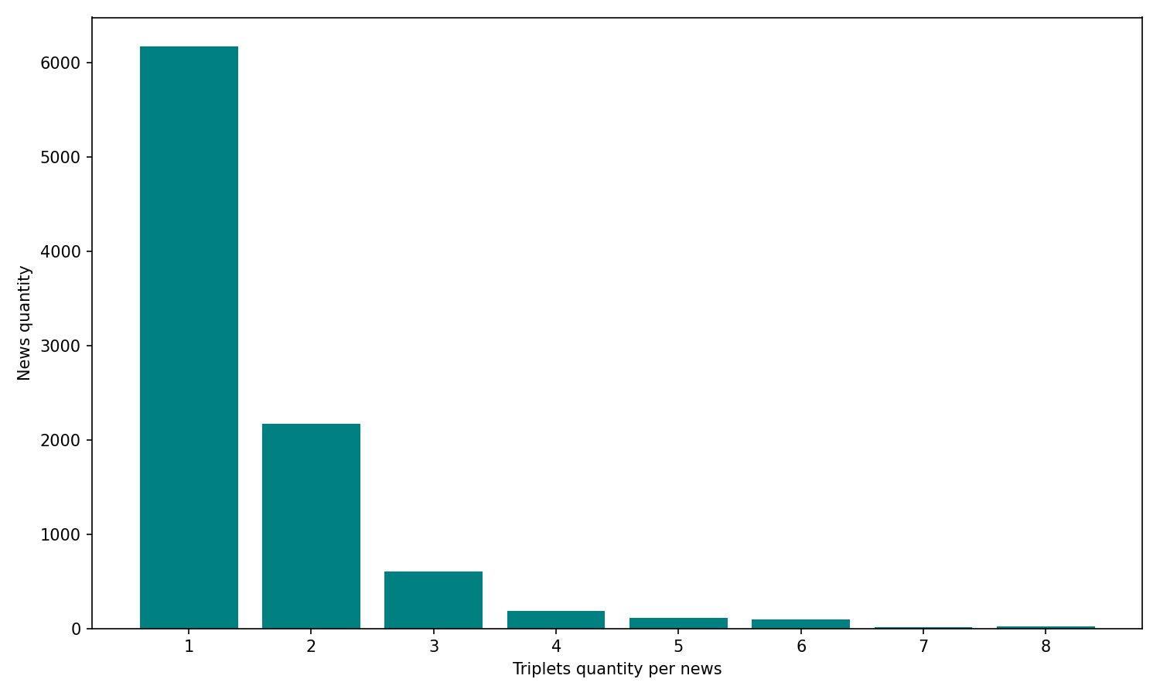
(a)
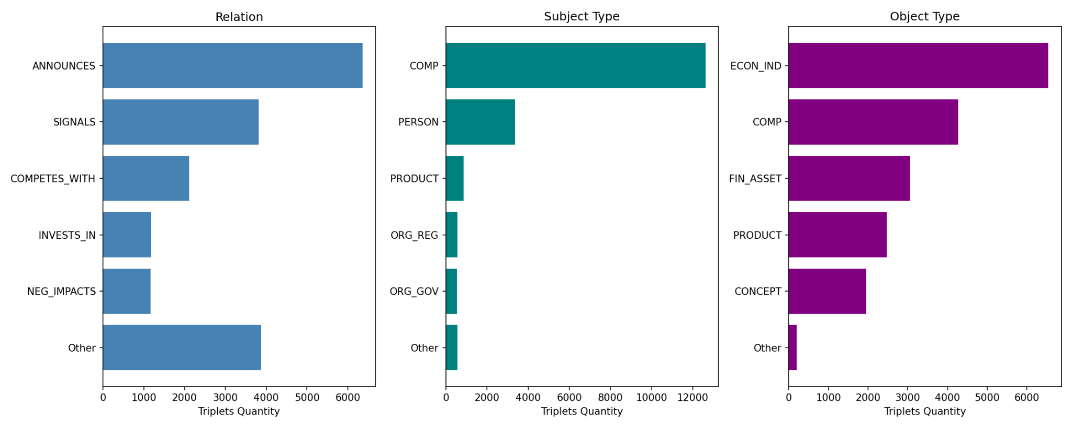
(b)
Fig. 3. Descriptive distributions of extracted knowledge triples: (a) Number of extracted triples per news article; (b) Triple distribution by relation type, subject entity type, and object entity type.
The figure reports the distribution of triples per news article, relation types, subject entity types, and object entity types after the prompt-based extraction process.
As shown in Table 6, the extraction pipeline processes 8,983 article-ticker pairs to produce 17,698 structured triples. The average article contains 516.4 tokens, whereas each extracted triple averages only 5.5 tokens. This compression ratio of approximately 94:1 reflects event-level distillation: each triple isolates a single financially relevant claim and its associated entities from the surrounding narrative, retaining the core financial facts needed for downstream modeling.
Figure 3 further supports this interpretation. Most articles yield one or two triples, indicating that the pipeline selects a small number of salient events per article rather than exhaustively fragmenting the text. The relation distribution is led by ANNOUNCES, SIGNALS, COMPETES_WITH, INVESTS_IN, and NEG_IMPACTS, which correspond respectively to corporate disclosures, forward-looking statements, competitive dynamics, capital deployment events, and adverse causal impacts. These categories represent distinct financial mechanisms rather than gradations of a single sentiment axis.
The subject and object distributions corroborate this finding. Subjects are predominantly companies, while objects span economic indicators, financial assets, products, and market concepts, a pattern that reflects the firm-level, event-driven structure of financial reporting. The news representation in NKTriF is therefore a knowledge-structured encoding of financial events, not a sentiment signal.

Macroeconomic data pipeline
Five daily macroeconomic indices are used to represent system-level market context: the CBOE Volatility Index (^VIX), the 10Y–2Y Treasury yield spread (DGS10 − DGS2 from FRED), the S&P 500 daily return (^GSPC), the US Dollar Index (DX-Y.NYB), and WTI crude oil (CL=F). Table 7 details the source and role of each index.
Table 7. Macroeconomic indices: sources and roles in NKTriF.
Index | Source | Ticker | Role
CBOE Volatility Index | Yahoo Finance | ^VIX | Represents market-implied volatility expectations
Yield Spread 10Y–2Y | FRED | DGS10 − DGS2 | Reflects business cycle signals and recession risk
S&P 500 daily return | Yahoo Finance | ^GSPC | Captures broad market momentum
US Dollar Index | Yahoo Finance | DX-Y.NYB | Reflects USD strength relative to major currencies
WTI crude oil | Yahoo Finance | CL=F | Proxies for energy and transportation cost conditions
The 10Y–2Y yield spread is constructed as the difference between the 10-year Treasury constant maturity rate (DGS10) and the 2-year rate (DGS2), both sourced from the Federal Reserve Economic Data (FRED) database. When FRED is unavailable, the pipeline substitutes Yahoo Finance proxies ^TNX and ^IRX as fallback series for the 10-year and 2-year yields respectively. These two intermediate series serve solely as inputs to the spread computation and do not enter the model as independent features.
All five indices are lagged by one trading day before being merged with the price data: the value recorded at time tt t is used as input when predicting $t+1$, ensuring that no information observable only after the target session enters the feature vector. Missing values arising from calendar mismatches across sources are resolved in two sequential passes: a backward fill initializes any leading observations at the start of each series where no prior value is available, and a forward fill propagates the most recent valid observation through any subsequent gaps. All five features are then z-scored using training-set statistics only, with the same parameters applied to the validation and test splits.

Dataset statistics and label distribution
The complete dataset spans 869 valid trading sessions from January 1, 2022, to June 23, 2025. After reserving the first 20 sessions as the initial look-back window, 849 usable time steps remain, producing 6,792 labeled samples across the eight equities. The dataset is partitioned chronologically into training (time steps 1–576), validation (577–720), and test (721–849) splits, corresponding to approximately 68%, 17%, and 15% of observations respectively, with no overlap between partitions.
The prediction target for each stock on each trading day is the next-session simple return on the close price:
${ret}_{t+1}=\frac{C_{t+1}-C_{t}}{{C_{t}}_{}}$
Each observation is assigned one of three directional labels based on where $ret_{t+1}$ falls relative to rolling 20-day percentile thresholds:
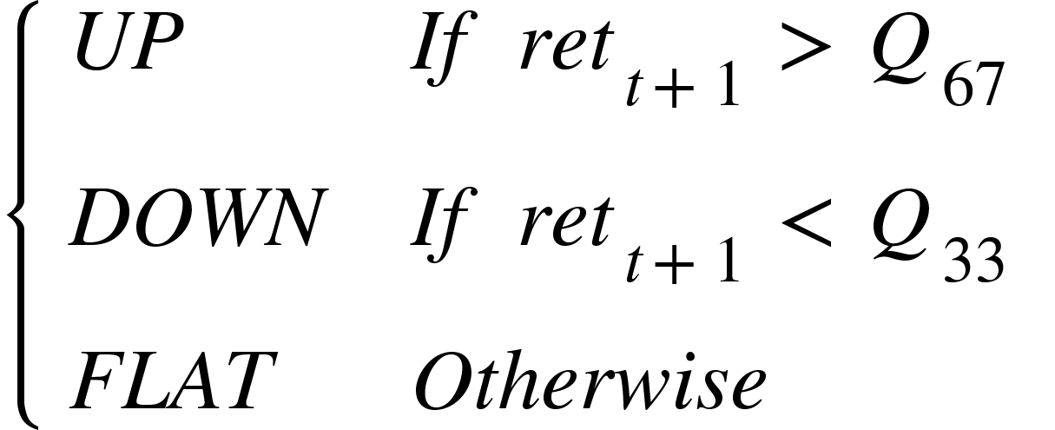
where $Q_{33}$ and $Q_{67}$ denote the 33rd and 67th percentiles of $ret$ computed over the preceding 20 trading sessions. Up indicates an above-average gain, down an above-average loss, and flat a return within the typical daily range. For the first 20 sessions, where insufficient history is available, training-set global percentiles are substituted. This adaptive boundary tracks local volatility regimes and eliminates the persistent class imbalance that arises when a fixed return threshold is applied across structurally different market periods.
Table 8 reports the resulting label distribution across the eight stocks. The three classes are near-perfectly balanced at approximately 33% each, a direct consequence of the symmetric percentile boundary. This near-balance eliminates the need for class weighting in the cross-entropy training objective and ensures that the MCC metric reflects genuine predictive performance across all three movement states rather than majority-class concentration.
Table 8. Label distribution across the experimental dataset.
Ticker | Sector | DOWN | FLAT | UP | Total
TSLA | Consumer Discretionary | 283 | 282 | 284 | 849
AAPL | Technology | 282 | 284 | 283 | 849
AMZN | Consumer Discretionary | 282 | 285 | 282 | 849
MSFT | Technology | 284 | 281 | 284 | 849
GOOGL | Technology | 283 | 282 | 284 | 849
META | Technology | 282 | 284 | 283 | 849
BA | Industrials | 284 | 281 | 284 | 849
WMT | Consumer Staples | 283 | 283 | 283 | 849
Total |  | 2,263 | 2,262 | 2,267 | 6,792

Evaluation metrics
Accuracy (ACC) measures the proportion of correctly classified samples across all three classes. It is reported for comparability with prior work but is a secondary metric in this study because, even under near-balanced class distributions, it does not distinguish between errors at the up/flat boundary and errors at the down/flat boundary - misclassification patterns with materially different implications for a trading decision.
Matthews Correlation Coefficient (MCC) is the primary evaluation metric. For multi-class classification, MCC is computed from the confusion matrix $C$ as:
$MCC=\frac{c⋅s-\sum_{k}{}p_{k}⋅t_{k}}{\sqrt{\left(s^{2}-\sum_{k}{}p_{k}^{2})(s^{2}-\sum_{k}{}t_{k}^{2}\right)}}$
where $c=\sum_{k}{}C_{kk}$ is the total number of correct predictions, $s=\sum_{k,l}{}C_{kl}$ is the total sample count, $p_{k}=\sum_{l}{}C_{lk}$ is the number of samples predicted as class $k$, and $t_{k}=\sum_{l}{}C_{kl}$ is the true count of class $k$. MCC $∈ [-1,1]$; higher values indicate better multi-class discrimination. MCC is preferred over accuracy as the primary metric because it accounts for all four confusion matrix entries equally across all three movement classes - including the flat category, whose misclassification accuracy tends to underweight.
All models are run with five independent random seeds. Mean ± standard deviation across seeds is reported for both metrics.

Baseline methods
Eight baseline models are organized into three groups according to input modality, enabling a controlled assessment of each modality's incremental contribution.
Group 1 - Price only. This group establishes the unimodal ceiling and reflects the performance achievable without any exogenous signal. LSTM is a standard two-layer Long Short-Term Memory network; the hidden state at the final time step serves as the sequence representation (Hochreiter & Schmidhuber, 1997). ALSTM augments LSTM with temporal attention that computes a weighted average over all hidden states in the observation window, allowing the model to emphasize more informative time steps (Feng et al., 2018).
Group 2 - Price + news. This group tests whether adding text information under simple or standard fusion mechanisms improves over the price-only baseline. ALSTM-W extends ALSTM with window-averaged FinBERT news embeddings, projected through a two-step bottleneck before concatenation with price features. SLOT (Soun et al., 2022) integrates per-timestep price and text representations through cross-projection within an ALSTM backbone. LLM-Stock (Xie et al., 2023) uses LLM sentence embeddings as the primary signal and price features as auxiliary input, following an in-context learning paradigm.
Group 3 - Price + macroeconomic indices. This group evaluates whether system-level market context improves prediction when combined with price, and how the integration mechanism affects outcomes. DA-RNN (Qin et al., 2017) applies input attention to select relevant macro features at each time step and temporal attention over encoder hidden states for the final prediction. ESTIMATE (Huynh et al., 2023) concatenates price and macro features before multi-head attention in a late-fusion design. DTML (Yoo et al., 2021) models temporal dependencies and cross-variable correlations simultaneously through a multi-level Transformer.
Uniform training protocol. All models are trained from scratch on the same dataset with the same chronological split, look-back window ($T=20$), and standard cross-entropy loss. All models with news branches use the same ProsusAI/FinBERT 768-dimensional embeddings. Hyperparameter selection is performed over an 18-combination grid: learning rate $∈$ {5e-5, 1e-4, 5e-4} × hidden dimension $∈$ {32, 64, 128} × dropout $∈$ {0.1, 0.2}; the combination maximizing validation MCC is selected before final evaluation on the test set.
NKTriF-specific hyperparameters. In addition to the shared grid, NKTriF uses the following architecture-specific settings: attention heads $M=4$; temporal decay coefficient $α=0.1$(selected from {0.05, 0.1, 0.2} on validation MCC); intermediate news projection dimension $d_{mid}=256$; ticker embedding dimension $d_{tid}=32$; quality vector dimension $d_{q}=64$; modality dropout probability $p=0.30$ (one auxiliary modality randomly zeroed per training batch). All NKTriF-specific values are held constant across the ablation and variant analyses reported in Sections 4.2–4.3, isolating the effect of the specific design choices under investigation in each experiment.

Results

Overall Performance and Baseline Comparison
Table 9 reports test-set performance aggregated over five independent random seeds for all nine baselines and NKTriF, grouped by input modality.
Table 9. Performance comparison of stock movement prediction models across all baselines.
Methods | Sources | ACC | MCC
LSTM | Price | 0.4193 ± 0.0087 | 0.1220 ± 0.0134
ALSTM | Price | 0.4139 ± 0.0079 | 0.1162 ± 0.0117
ALSTM-W | Price + news | 0.3799 ± 0.0073 | 0.0642 ± 0.0115
SLOT | Price + news | 0.3709 ± 0.0073 | 0.0503 ± 0.0080
LLM-Stock | Price + news | 0.3680 ± 0.0074 | 0.0425 ± 0.0106
DA-RNN | Price + macro | 0.4268 ± 0.0068 | 0.1300 ± 0.0123
ESTIMATE | Price + macro | 0.3986 ± 0.0069 | 0.0996 ± 0.0105
DTML | Price + macro | 0.4188 ± 0.0045 | 0.1236 ± 0.0077
NKTriF (Proposed) | Price + news + macro | 0.4324 ± 0.0086 | 0.1394 ± 0.0152
Bold: best result per metric; Underlined: second-best result per metric.
Firstly, the performance comparison shows that NKTriF consistently achieves the best performance across both metrics. NKTriF attains ACC = 0.4324 and MCC = 0.1394, surpassing the second-best model DA-RNN by margins of +1.3% on ACC and +7.2% on MCC. DA-RNN is a strong attention-based architecture designed for multivariate time series, making this gap particularly informative. The fact that NKTriF maintains its advantage against a high-capacity competitor suggests that the performance gains stem from its trimodal integration strategy rather than from favorable dataset characteristics alone.
Secondly, augmenting price sequences with news data does not yield consistent improvements without an appropriate integration mechanism. All three Price + News models underperform the unimodal LSTM baseline on MCC. Specifically, ALSTM-W (0.0642), SLOT (0.0503), and LLM-Stock (0.0425) each fall well below LSTM (0.1220). This pattern indicates that raw textual signals introduce noise that simple fusion strategies cannot suppress. In contrast, NKTriF addresses this by structuring news content into knowledge triples and applying a gated fusion mechanism, enabling the model to selectively incorporate informative signals while attenuating noisy ones.
Furthermore, we found that the predictive value of macroeconomic data depends strongly on the extraction mechanism rather than on data availability alone. Within the Price + Macro group, DA-RNN (MCC = 0.1300) and DTML (MCC = 0.1236) achieve competitive results, while ESTIMATE lags at MCC = 0.0996 despite using the same category of input. This discrepancy suggests that the architectural capacity to selectively attend to relevant macroeconomic signals is as consequential as the signals themselves, a finding that further motivates the design of NKTriF's cross-modal attention module.
In conclusion, the results demonstrate a consistent design principle: the value of additional modalities in financial prediction is contingent on representation quality, fusion control, and integration architecture. Adding raw text or macroeconomic features without appropriate mechanisms can degrade rather than improve performance, confirming that architectural choices are at least as consequential as data availability.
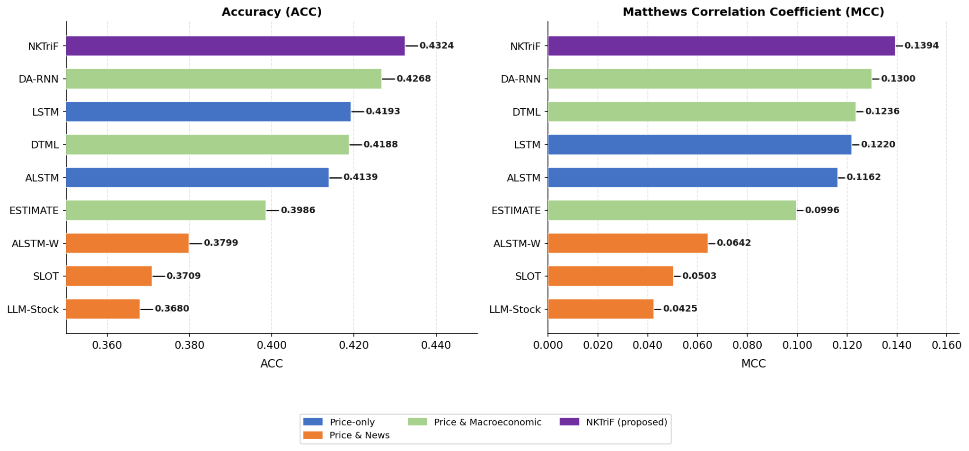
Fig. 4. Performance benchmark of NKTriF against baseline models across ACC and MCC.

Individual modality contribution
In this subsection, we examine how each auxiliary modality contributes to the overall predictive performance of NKTriF. To evaluate this, we implement two ablation variants in which one auxiliary modality is removed and the model is retrained from scratch under identical hyperparameters: 1) NKTriF-PM (price + macro): a version in which the news branch is excluded, retaining only price and macroeconomic inputs; 2) NKTriF-PN (price + news): a version in which the macro branch is excluded, retaining only price and news inputs. ΔMCC is computed relative to the full model; a negative value indicates performance degradation upon removal, reflecting a positive marginal contribution of the omitted modality. The performance of these variants is shown in Table 10, and the contribution of each data modality in the NKTriF model is shown in Figure 5.
Table 10. Ablation results on modality contribution across two evaluation metrics.
Variant | ACC | MCC | ΔMCC
NKTriF | 0.4324 ± 0.0086 | 0.1394 ± 0.0152 | -
NKTriF-PM | 0.4107 ± 0.0077 | 0.1048 ± 0.0098 | −0.0346
NKTriF-PN | 0.4170 ± 0.0227 | 0.1148 ± 0.0321 | −0.0246
ΔMCC relative to NKTriF: Negative ΔMCC indicates performance degradation upon removal, reflecting a positive marginal contribution of the removed modality.
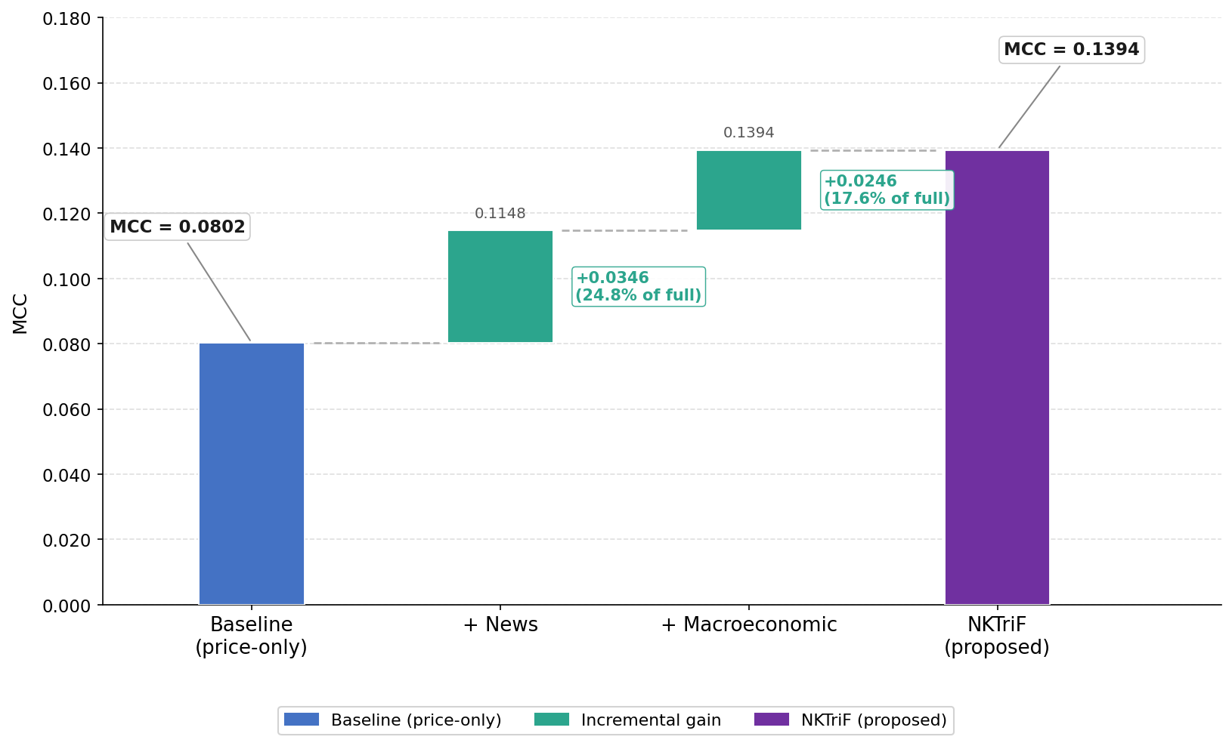
Fig. 5. Incremental performance gains from integrating news sentiment and macroeconomic indicators.
News yields the larger mean MCC gain, while macro contributes primarily to prediction stability. NKTriF-PM reduces MCC by 0.0346 points, indicating that the news branch carries stronger directional signal for next-session prediction than the macro branch. NKTriF-PN, by contrast, reduces MCC by only 0.0246 points but doubles standard deviation from 0.0152 to 0.0321 (×2.1), whereas NKTriF-PM narrows standard deviation to 0.0098. The two modalities therefore play functionally distinct roles: news drives mean accuracy, while macro regularizes prediction consistency across seeds and market conditions.
Crucially, these modality contributions are non-additive. Although the combined linear loss across independent ablations sums to a ΔMCC of −0.0592, the full trimodal architecture achieves a baseline expansion that exceeds the mere aggregation of individual parts. This non-linear synergy validates the sequential gating framework: the economic and statistical advantages of NKTriF do not stem from isolated feature pools, but rather from the interaction-aware latent representations generated as price metrics adaptively regulate the cascading intake of event and regime signals.

Effect of stable gating mechanism
In this subsection, we examine whether the sigmoid gating mechanism constitutes a necessary architectural component. To evaluate this, we implement one ablation variant: NKTriF-NoGate, a version in which the sigmoid gate is replaced by direct residual addition of the cross-attention output, with all other components held constant. The performance of this variant relative to the full model is shown in Table 11.
Table 11. Performance comparison between gated and non-gated fusion variants across two evaluation metrics.
Variant | ACC | MCC
NKTriF | 0.4324 ± 0.0086 | 0.1394 ± 0.0152
NKTriF-NoGate | 0.4131 ± 0.0248 | 0.1074 ± 0.0346
Gated fusion improves both mean MCC and cross-seed consistency. NKTriF achieves MCC = 0.1394, 0.0320 points above NKTriF-NoGate (0.1074), while standard deviation decreases 2.3× from 0.0346 to 0.0152. The gate therefore contributes to both mean accuracy and initialization robustness simultaneously.
Non-gated cross-attention is capable under favorable initialization but lacks consistency. Across five seeds, NKTriF-NoGate spans an observed MCC range of 0.1023 (0.0485 to 0.1508). Its upper bound of 0.1508 is competitive with the full model mean of 0.1394, indicating that cross-attention alone can locate useful auxiliary signals under favorable conditions, but fails to do so reliably. The sigmoid gate, by conditioning auxiliary intake on the price representation at each time step, provides a selection mechanism anchored to the most reliable modality in the input, producing a substantially tighter performance envelope across seeds. The 2.3× variance reduction is arguably the more consequential result from a deployment perspective, where prediction consistency matters as much as mean performance.
In conclusion, the gated cross-attention mechanism contributed both to mean MCC and to cross-seed robustness. The 2.3× reduction in MCC variance is arguably the more consequential finding for practical deployment, where prediction consistency matters as much as mean performance. The gate's role is best understood as adaptive noise regulation, which learns to suppress auxiliary contributions at conflicting positions rather than as a feature transformation.

Effect of auxiliary integration order
In this subsection, we examine whether the sequence in which auxiliary modalities are integrated affects predictive performance. To evaluate this, we implement three variants holding the gated cross-attention mechanism constant: 1) NKTriF-NM: the full NKTriF architecture in which news is integrated first, followed by macro; 2) NKTriF-MN: a sequential configuration in which macro is integrated first, followed by news; 3) NKTriF-Par: a parallel configuration in which news and macro branches are processed independently and their outputs averaged before prediction. The performance of these variants is shown in Table 12.
Table 12. Performance comparison of fusion order variants across two evaluation metrics.
Variant | ACC | MCC | ΔMCC
NKTriF-NM | 0.4324 ± 0.0086 | 0.1394 ± 0.0152 | -
NKTriF-MN | 0.4199 ± 0.0150 | 0.1163 ± 0.0228 | −0.0231
NKTriF-Par | 0.4252 ± 0.0105 | 0.1242 ± 0.0169 | −0.0152
News-first sequential fusion achieves the highest MCC and lowest variance among the three configurations. NKTriF-NM attains MCC = 0.1394 with std = 0.0152. NKTriF-MN records the largest degradation at -0.0231 MCC points with std rising to 0.0228, while NKTriF-Par is intermediate at -0.0152 MCC points with std = 0.0169. The advantage of NKTriF-NM holds consistently across both dimensions, indicating that fusion order has a measurable effect on model behavior beyond random variation.
Reversing the fusion order impairs both accuracy and stability more than parallel fusion does. NKTriF-MN records the lowest MCC and highest variance among all three variants. This collapse, which underperforms even the symmetric parallel baseline, reveals an inherent structural constraint: pre-conditioning the model's latent representation with slow-moving macroeconomic features early saturates the latent space with background systemic context. Consequently, the network loses its representational capacity to effectively ingest and resolve the sharper, short-horizon event-driven signals from the subsequent news branch.
The advantage of NKTriF-NM over NKTriF-Par warrants cautious interpretation. The MCC gap between the two is 0.0152 points - comparable in magnitude to the standard deviation of NKTriF-NM (0.0152) - and should be treated as a directional trend rather than a conclusive finding. The advantage over NKTriF-MN is more pronounced at 0.0231 points and consistent across seeds, providing stronger empirical support for the news-first ordering. Formal significance testing with additional seeds is required before the sequential ordering advantage over parallel fusion can be considered robust.
In conclusion, the sequential news-first fusion order was the best-performing configuration in this experimental setting on both mean MCC and stability. The pattern is consistent with the hypothesis that news and macroeconomic indices play functionally asymmetric roles in short-horizon stock movement prediction.

Effect of hyperparameters
- Impact of hidden dimension size
We investigate the impact of different hidden embedding dimension sizes, setting $d ∈[32,64,128,256]$. As shown in Figure 6, model performance follows a unimodal pattern across both metrics: improving from $d=32$ to $d=64$, then degrading monotonically at larger sizes. This reflects a capacity–generalization trade-off - $d=32$ provides insufficient expressive capacity to capture interactions across the three input modalities, while $d=128$ and $d=256$ introduce excessive parameters that overfit the limited financial training data. Notably, the degradation beyond $d=64$ is gradual rather than abrupt, suggesting mild overfitting rather than optimization failure. Considering both performance and efficiency, we select $d=64$ as the optimal hidden dimension size.
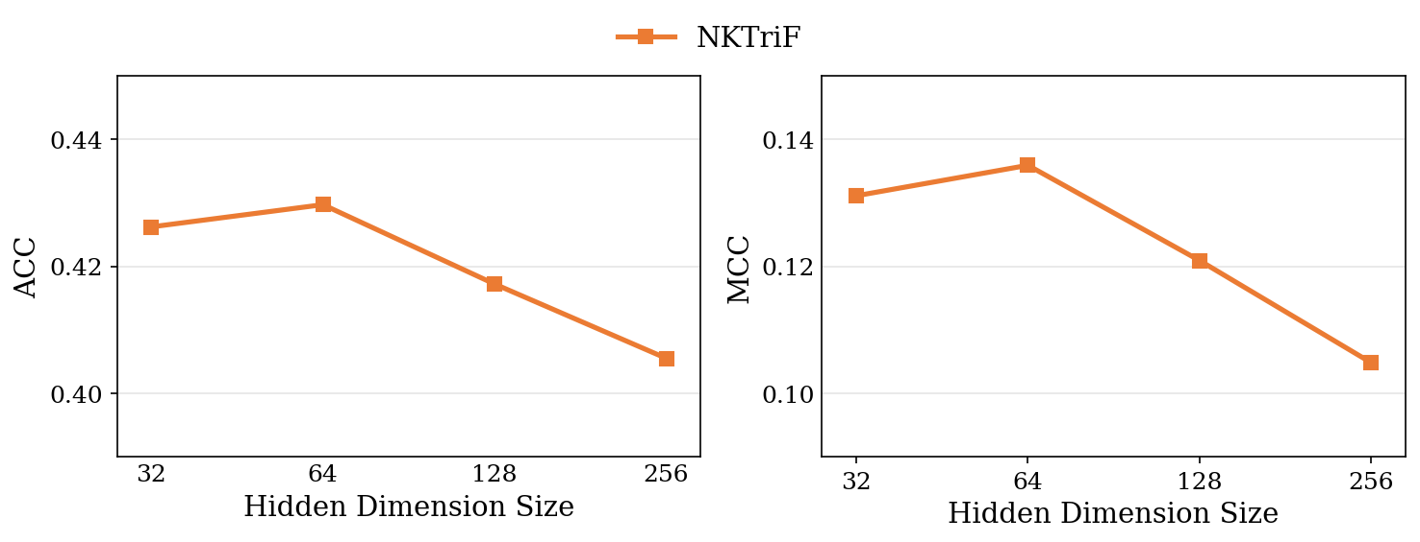
Fig. 6. Performance of NKTriF with various hidden dimension sizes.
- Impact of learning rate
The learning rate is a critical hyperparameter governing convergence behavior. We evaluate $lr ∈[1e-3, 5e-4, 1e-4, 5e-5]$. As shown in Fig. 7, performance also follows a unimodal pattern, peaking at $1e-4$. High learning rates ($1e-3$, $5e-4$) cause the optimizer to overshoot the loss minimum, producing the largest degradation - consistent with a relatively sharp loss landscape near the optimum. Reducing to $5e-5$ yields a smaller but still meaningful decline, as the fixed training budget is insufficient for slower gradient descent to reach the optimal loss basin. The asymmetry between the two failure modes - overshooting being more damaging than undershooting - suggests that convergence speed is the more critical failure mode for NKTriF. Accordingly, we set $1e-4$ as the optimal learning rate in our experiments.
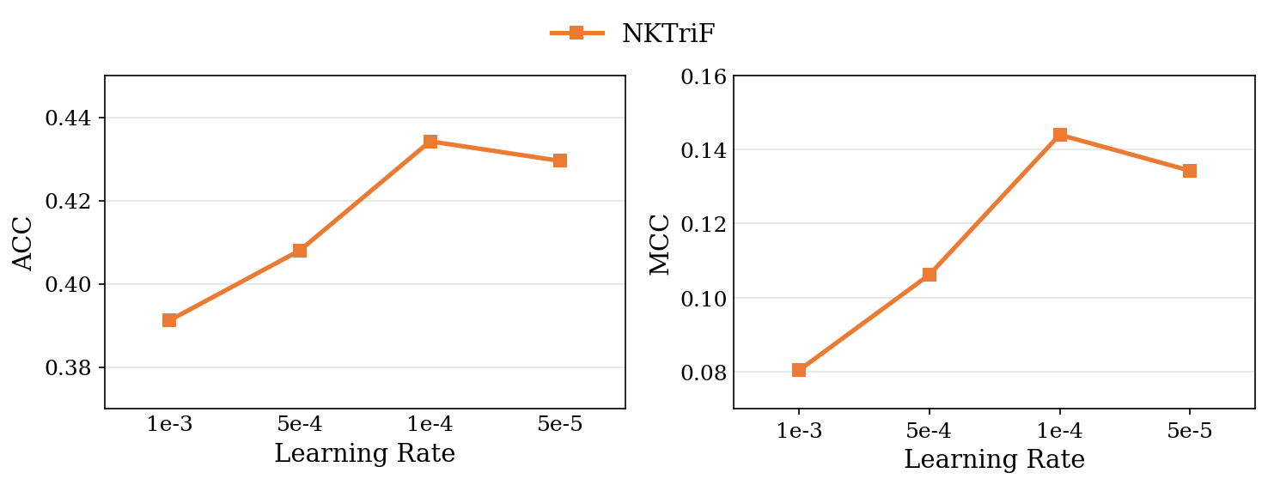
Fig. 7. Performance of NKTriF with various learning rates.
- Impact of window size
We evaluate the influence of the input sequence length, setting $ws∈[10,15,20,25]$. As shown in Fig. 8, performance again follows a unimodal pattern, peaking at $ws=20$ with the lowest variance across seeds, then declining at $ws=25$. The degradation at $ws=10$ is substantially larger than at $ws=25$ - the gap from the optimum is approximately 3.5× wider in the short-window direction, which indicates that insufficient historical context is a more damaging failure mode than marginal over-extension. At $ws=10$, the sequence is too short to encode meaningful temporal dynamics across price, news, and macroeconomic modalities, while the higher variance suggests the model becomes more sensitive to initialization under data-sparse conditions. Beyond $ws=20$, the marginal information gain from additional timesteps is offset by the reduced number of available training samples, limiting what the model can learn from the longer sequences. Notably, $ws=20$ also requires the most training epochs to converge, consistent with a richer but more complex optimization landscape. We therefore select $ws=20$ as the optimal window size, as it provides the best balance between temporal coverage and training sample availability.
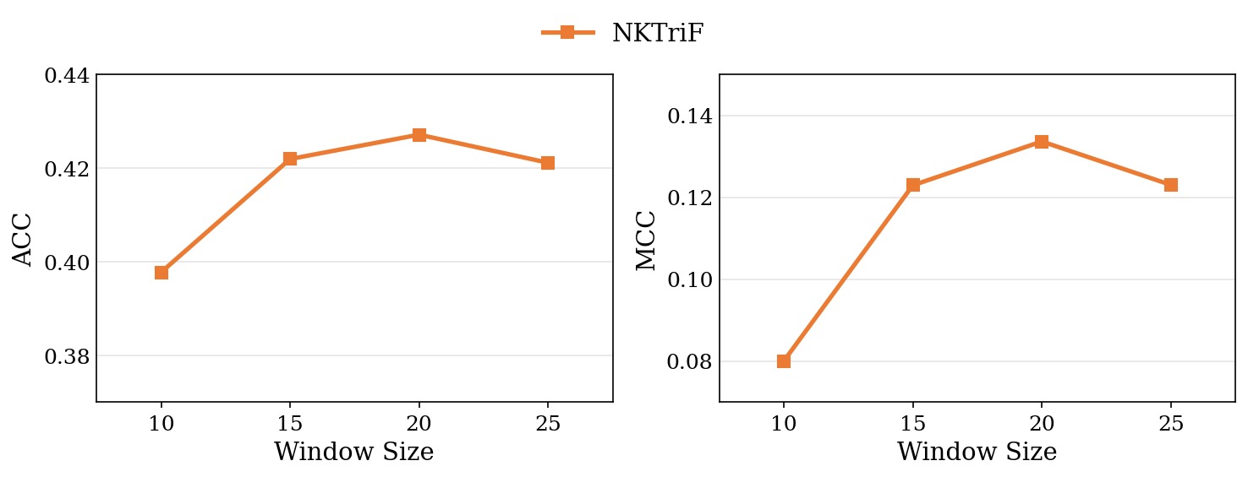
Fig. 8. Performance of NKTriF with various window sizes.

Trading simulation
While ACC and MCC measure classification quality at the label level, they do not capture whether the model's probabilistic outputs translate into economically useful signals. This section presents a supplementary trading simulation to illustrate that connection.
- Decision Signal
For each asset $i$ on trading day $t$, the inference layer yields a three-class probability distribution $p_{i,t}=\left[P_{DOWN,i,t},P_{FLAT,i,t},P_{UP,i,t}\right]$. A continuous directional signal ${Score}_{i,t}$ is defined as:
${Score}_{i,t}=P_{UP,i,t}-P_{DOWN,i,t}∈\left[-1,+1\right]$
where a positive or negative value represents net upward or downward expectations, respectively. Crucially, the fine-grained $FLAT$ class acts as an implicit volatility filter. Under low-conviction or highly uncertain market states , the model assigns dominant probability mass to $P_{FLAT,i,t}$, naturally compressing both $P_{UP,i,t}$ and $P_{DOWN,i,t}$. This automatically drives $\left|{Score}_{i,t}\right|$ toward zero, dynamically dampening capital commitment and preventing excessive trading during uninformative periods without requiring an arbitrary confidence threshold.
- Trading Strategy
The portfolio executes a daily confidence-weighted rebalancing strategy across the asset universe. Let $L_{t}^{+}$ and $L_{t}^{-}$ denote the constituent sets with positive and negative scores on day $t$. To isolate idiosyncratic alpha and guarantee strict immunization against systematic market beta, total capital $C$ is divided equally between the long and short legs ($\sum{}w_{i,t}^{+}=\sum{}w_{i,t}^{-}=C/2$). The specific asset weight allocations are formalized as:
$w_{i,t}^{+}=\frac{1}{2}⋅C⋅\frac{{Score}_{i,t}}{\sum_{j∈L_{t}^{+}}{}{Score}_{j,t}}, ∀i∈L_{t}^{+}$
$w_{i,t}^{-}=\frac{1}{2}⋅C⋅\frac{\left|{Score}_{i,t}\right|}{\sum_{j∈L_{t}^{-}}{}\left|{Score}_{j,t}\right|}, ∀i∈L_{t}^{-}$
- Evaluation Metrics
To evaluate risk-adjusted efficiency and alpha generation under realistic friction, all portfolio returns are calculated net of a 4 basis points (bps) per-side transaction cost and evaluated against two standard performance metrics:
- Annualized Sharpe Ratio - Quantifies risk-adjusted returns (assuming a 0% risk-free rate) formalized as:
$Sharpe=\frac{rˉ}{σ(r)}⋅\sqrt{252}$
where $rˉ$ and $σ(r)$ represent the sample mean and standard deviation of daily portfolio returns, respectively.
- Geometric Annualized Return - Compresses the compounded growth rate over the T-day evaluation horizon:
$Ann. Return={\left(\prod_{t=1}^{T}{}(1+r_{t})\right)}^{252/T}-1$
The execution policy is benchmarked against two passive reference controls to isolate the model's market-independent predictive value:
- Buy-and-Hold: Maintains an equally weighted, static long position across all 8 tickers throughout the test period.
- Random Monte Carlo (MC): Generates uniform random daily scores $∈ [-1,+1]$ per ticker and applies identical portfolio weight allocation mechanics. The benchmark output is systematically averaged over 1,000 independent stochastic runs to establish the expected return baseline of zero-conviction trading.
- Results
Net-of-transaction-costs performance metrics over the backtest period are summarized in Table 13.
Table 13. Financial performance and risk-adjusted returns in net-of-cost trading simulations.
Model | Sharpe (net TC) | Ann. Return
NKTriF (ours) | +0.85 | +27.68%
LSTM | +0.78 | +26.98%
LLM-Stock | +0.65 | +14.02%
DA-RNN | +0.26 | +3.79%
SLOT | −0.32 | +1.55%
ALSTM | −0.30 | −3.17%
ESTIMATE | −0.24 | −4.00%
ALSTM-W | −0.82 | −5.37%
DTML | −0.86 | −19.67%
Buy-and-Hold | - | −4.56%
To further illustrate the temporal dynamics underlying these aggregate statistics, Figure 9 traces the day-by-day evolution of cumulative portfolio wealth for all models throughout the 140-day test period.
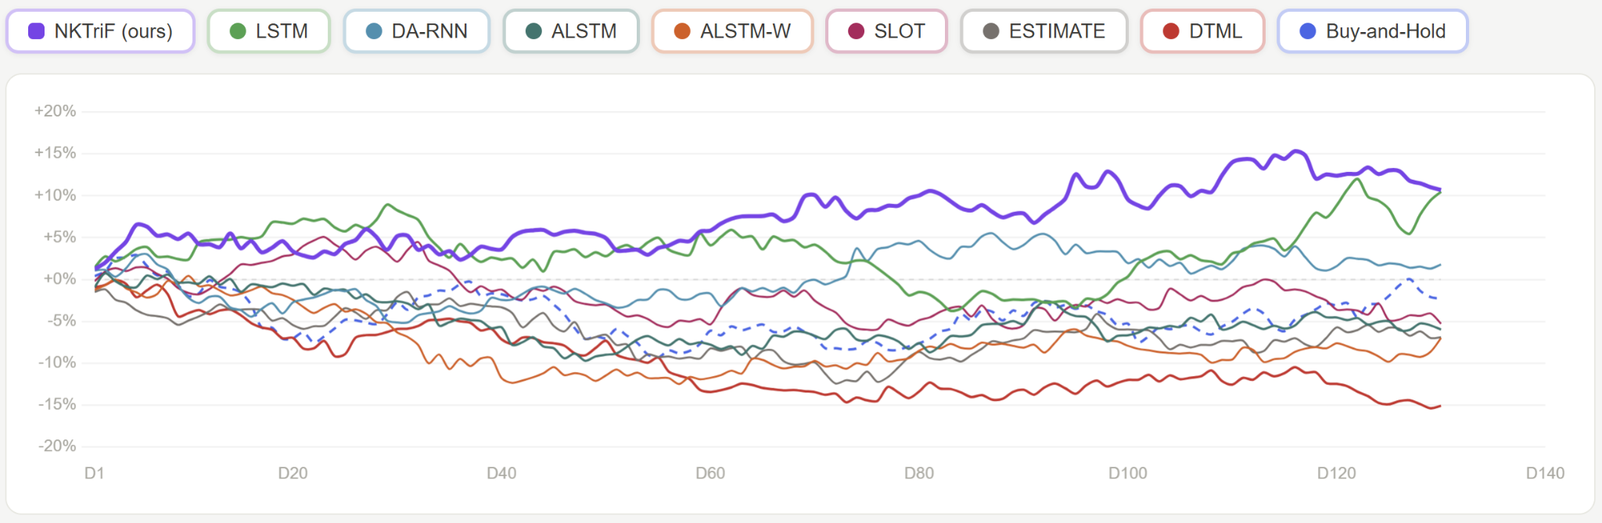
Fig. 9. Cumulative Wealth of Portfolio Strategies Over the Test Period
The empirical results in Figure 9 show two critical insights:
- NKTriF achieves the highest risk-adjusted profile, yielding a net-TC Sharpe ratio of +0.85 and an annualized return of +27.68% , significantly outperforming the passive Buy-and-Hold benchmark ($-4.56\%$).
- Naive multimodal integration strategies exhibit severe economic degradation; ALSTM-W ($-0.82$ Sharpe) and DTML ($-0.86$ Sharpe) substantially underperform the price-only LSTM baseline ($+0.78$ Sharpe). This collapse demonstrates that fusing raw text or macroeconomic features without explicit regulation introduces high-frequency representation noise. Minor daily fluctuations in uncalibrated auxiliary signals cause erratic logit shifts, generating excessive portfolio turnover (churn) that allows transaction fees to completely erode trading returns.
In contrast, the economic resilience of NKTriF validates its two-stage gated architecture and flat-state regulation. By sequentially anchoring auxiliary inputs to historical price series and filtering cross-modal conflicts via the price-conditioned gate , the framework suppresses transient noise, minimizes rebalancing turnover, and preserves capital during low-conviction regimes while consistently extracting robust cross-sectional alpha.

Discussion and conclusion

Discussion
The empirical results demonstrate that multimodal integration enhances short-horizon stock price forecasting only when modality-specific noise is explicitly controlled. This finding aligns with Baltrusaitis et al. (2019), who identify representation heterogeneity and data incompleteness as the primary challenges in multimodal machine learning. In this study, all baseline models combining price and raw news underperformed the univariate price-only LSTM, consistent with the interpretation that raw financial text introduces significant linguistic noise that standard symmetric fusion strategies cannot filter - a pattern Zong et al. (2025) similarly observe in naive multimodal fusion. NKTriF addresses this limitation through its structured knowledge-triple extraction pipeline and gated cross-attention framework. The 2.3× variance reduction achieved by the gated configuration over the non-gated alternative demonstrates that a price-conditioned gate stabilizes optimization, supporting the theoretical motivations for gated networks presented by Srivastava et al. (2015) and Dauphin et al. (2017).
The ablation experiments further confirm that news and macroeconomic indices play functionally asymmetric roles in short-horizon stock movement prediction. News drives mean prediction quality by carrying concentrated short-horizon event signals, consistent with Tetlock's (2007) finding that media-driven price effects dissipate within one to two sessions. Macro improves prediction stability by providing slow-moving regime context, consistent with Cont's (2001) characterization of macroeconomic variables as regime-level rather than event-level signals. This asymmetry dictates that fusion order matters: integrating macro first saturates the latent space with background context before news can be absorbed, producing the largest performance degradation among all fusion variants.
Furthermore, the results show that the gate's primary contribution is reliability rather than ceiling performance. The non-gated variant can match or exceed the full model's mean under favorable initialization, but fails to do so consistently. By anchoring auxiliary intake to the price representation at each step, the gate replaces initialization-dependent attention with a stable selection mechanism - a distinction that matters more in deployment than in best-case evaluation.
Finally, the trading simulation confirms the classification findings through an independent economic lens. NKTriF achieves the strongest risk-adjusted profile among all models. More revealing is the divergence between DTML's competitive classification performance and its poor economic outcome. It suggests that its predictions lack the session-level consistency required for stable position sizing. The same pattern holds across Group 2: the weakest multimodal baselines by MCC also produce the most negative Sharpe ratios, confirming that unregulated fusion harms economic utility as severely as it harms classification quality.

Conclusion
This study demonstrates that structured knowledge extraction from financial news, combined with macroeconomic context and a price-anchored gated cross-attention fusion mechanism, consistently improves fine-grained three-class stock movement prediction across a multi-regime evaluation window.
Two structural limitations bound the generalizability of these conclusions. First, the framework was developed and evaluated on English-language news covering high-coverage US large-cap equities. Extending it to the Vietnamese market faces infrastructure challenges that differ qualitatively from the US context. Vietnamese financial news is dispersed across multiple outlets - Cafef, VietnamBiz, Vietstock - without standardized ticker-tagging APIs comparable to Alpaca or Bloomberg feeds. Articles routinely reference companies by full Vietnamese name without ticker identifiers, requiring entity disambiguation before any extraction pipeline can operate. No domain-specific language model equivalent to FinBERT exists for Vietnamese financial text. PhoBERT (Nguyen & Nguyen., 2020), the closest available model, has not been adapted for financial entity and relation extraction at the granularity NKTriF's triple pipeline requires. Prior work on Vietnamese stock market text mining has identified insufficient NLP tooling for Vietnamese as a primary barrier to more accurate prediction outcomes (Duong et al., 2016) .
Second, the architecture operates at daily granularity, leaving periodic financial disclosures, such as quarterly earnings reports, annual filings, and earnings call transcripts, outside its representational scope. These documents carry forward-looking guidance relevant across multiple subsequent sessions, yet their low publication frequency is fundamentally incompatible with the daily fusion mechanism. Incorporating them would require a dedicated propagation mechanism to diffuse disclosure-level signals across intervening daily time steps, an architectural extension not addressed in the current design.
Future work follows directly from these limitations. For the Vietnamese market context, the primary prerequisite is a structured news collection pipeline with robust company-to-ticker resolution for Vietnamese entities, paired with a domain-adapted language model for financial triple extraction - either through fine-tuning PhoBERT on annotated Vietnamese financial corpora or by extending LLM-based extraction with Vietnamese financial few-shot examples. For multi-scale temporal integration, a periodic disclosure encoder with explicit temporal decay across post-publication sessions would enable the model to leverage earnings and filing signals without conflating their long-horizon relevance with the session-specific nature of daily news.

REFERENCES
Baltrusaitis, T., Ahuja, C., & Morency, L.-P. (2019). Multimodal machine learning: A survey and taxonomy. IEEE Transactions on Pattern Analysis and Machine Intelligence, 41(2), 423–443. https://doi.org/10.1109/TPAMI.2018.2798607
Bengio, Y., Simard, P., & Frasconi, P. (1994). Learning long-term dependencies with gradient descent is difficult. IEEE Transactions on Neural Networks, 5(2), 157–166.
Board of Governors of the Federal Reserve System. (2023). Monetary policy report, March 2023. Board of Governors of the Federal Reserve System. https://www.federalreserve.gov/monetarypolicy/2023-03-mpr-summary.htm
Bollerslev, T. (1986). Generalized autoregressive conditional heteroskedasticity. Journal of Econometrics, 31(3), 307–327.
Box, G. E. P., & Jenkins, G. M. (1976). Time series analysis: Forecasting and control (Rev. ed.). Holden-Day.
Cho, K., Van Merriënboer, B., Gulçehre, Ç., Bahdanau, D., Bougares, F., Schwenk, H., & Bengio, Y. (2014). Learning phrase representations using RNN encoder–decoder for statistical machine translation. In Proceedings of the 2014 Conference on Empirical Methods in Natural Language Processing (pp. 1724–1734). Association for Computational Linguistics. https://doi.org/10.3115/v1/D14-1179
Cont, R. (2001). Empirical properties of asset returns: Stylized facts and statistical issues. Quantitative Finance, 1(2), 223–236. https://doi.org/10.1080/713665670
Dauphin, Y. N., Fan, A., Auli, M., & Grangier, D. (2017). Language modeling with gated convolutional networks. In Proceedings of the 34th International Conference on Machine Learning (pp. 933–941). PMLR.
Devlin, J., Chang, M.-W., Lee, K., & Toutanova, K. (2019). BERT: Pre-training of deep bidirectional transformers for language understanding. In Proceedings of the 2019 Conference of the North American Chapter of the Association for Computational Linguistics: Human Language Technologies (pp. 4171–4186). Association for Computational Linguistics. https://doi.org/10.18653/v1/N19-1423
Ding, X., Zhang, Y., Liu, T., & Duan, J. (2015). Deep learning for event-driven stock prediction. In Proceedings of the 24th International Joint Conference on Artificial Intelligence (pp. 2327–2333). AAAI Press.
Dolphin, R., Smyth, B., Dong, R., Lawlor, A., & Cunningham, P. (2024). Extracting structured insights from financial news: An augmented LLM driven approach. arXiv preprint arXiv:2407.15788. https://doi.org/10.48550/arXiv.2407.15788
Duong, D., Nguyen, T., & Dang, M. (2016, January). Stock market prediction using financial news articles on Ho Chi Minh Stock Exchange. In Proceedings of the 10th International Conference on Ubiquitous Information Management and Communication (pp. 1–6). ACM.
Engle, R. F. (1982). Autoregressive conditional heteroscedasticity with estimates of the variance of United Kingdom inflation. Econometrica: Journal of the Econometric Society, 50(4), 987–1007.
Feng, F., Chen, H., He, X., Ding, J., Sun, M., & Chua, T.-S. (2018). Enhancing stock movement prediction with adversarial training. arXiv:1810.09936. https://arxiv.org/abs/1810.09936
Fischer, T., & Krauss, C. (2018). Deep learning with long short-term memory networks for financial market predictions. European Journal of Operational Research, 270(2), 654–669. https://doi.org/10.1016/j.ejor.2017.11.054
Fukui, A., Park, D. H., Yang, D., Rohrbach, A., Darrell, T., & Rohrbach, M. (2016). Multimodal compact bilinear pooling for visual question answering and visual grounding. In Proceedings of the 2016 Conference on Empirical Methods in Natural Language Processing (pp. 457–468). Association for Computational Linguistics. https://doi.org/10.18653/v1/D16-1044
Greff, K., Srivastava, R. K., Koutnik, J., Steunebrink, B. R., & Schmidhuber, J. (2017). LSTM: A search space odyssey. IEEE Transactions on Neural Networks and Learning Systems, 28(10), 2222–2232. https://doi.org/10.1109/TNNLS.2016.2582924
Hochreiter, S., & Schmidhuber, J. (1997). Long short-term memory. Neural Computation, 9(8), 1735–1780. https://doi.org/10.1162/neco.1997.9.8.1735
Hu, Z., Liu, W., Bian, J., Liu, X., & Liu, T.-Y. (2018). Listening to chaotic whispers: A deep learning framework for news-oriented stock trend prediction. In Proceedings of the 11th ACM International Conference on Web Search and Data Mining (pp. 261–269). ACM. https://doi.org/10.1145/3159652.3159690
Huang, A. H., Wang, H., & Yang, Y. (2023). FinBERT: A large language model for extracting information from financial text. Contemporary Accounting Research, 40(2), 806–841. https://doi.org/10.1111/1911-3846.12832
Huynh, T. T., Nguyen, M. H., Nguyen, T. T., Nguyen, P. L., Weidlich, M., Nguyen, Q. V. H., & Aberer, K. (2023). Efficient integration of multi-order dynamics and internal dynamics in stock movement prediction. In Proceedings of the Sixteenth ACM International Conference on Web Search and Data Mining (pp. 850–858). ACM. https://doi.org/10.1145/3539597.3570427
International Monetary Fund. (2025). Global financial stability report: April 2025. International Monetary Fund. https://www.imf.org/en/publications/gfsr/issues/2025/04/22/global-financial-stability-report-april-2025
Krauskopf, L. (2023, December 28). Can sizzling Magnificent Seven trade keep powering U.S. stocks in 2024? Reuters.
Lu, J., Yang, J., Batra, D., & Parikh, D. (2016). Hierarchical question-image co-attention for visual question answering. In Advances in Neural Information Processing Systems (Vol. 29, pp. 289–297). Curran Associates.
Mikolov, T., Chen, K., Corrado, G., & Dean, J. (2013). Efficient estimation of word representations in vector space. arXiv:1301.3781. https://arxiv.org/abs/1301.3781
Nguyen, D. Q., & Nguyen, A. T. (2020). PhoBERT: Pre-trained language models for Vietnamese. In Findings of the Association for Computational Linguistics: EMNLP 2020 (pp. 1037–1042). Association for Computational Linguistics. https://doi.org/10.18653/v1/2020.findings-emnlp.92
Peters, M. E., Neumann, M., Iyyer, M., Gardner, M., Clark, C., Lee, K., & Zettlemoyer, L. (2018). Deep contextualized word representations. In Proceedings of the 2018 Conference of the North American Chapter of the Association for Computational Linguistics: Human Language Technologies (Vol. 1, pp. 2227–2237). Association for Computational Linguistics. https://doi.org/10.18653/v1/N18-1202
Qin, Y., Song, D., Cheng, H., Cheng, W., Jiang, G., & Cottrell, G. W. (2017). A dual-stage attention-based recurrent neural network for time series prediction. In Proceedings of the 26th International Joint Conference on Artificial Intelligence (pp. 2627–2633). AAAI Press. https://doi.org/10.24963/ijcai.2017/366
Reimers, N., & Gurevych, I. (2019). Sentence-BERT: Sentence embeddings using Siamese BERT-networks. In Proceedings of the 2019 Conference on Empirical Methods in Natural Language Processing (pp. 3982–3992). Association for Computational Linguistics. https://doi.org/10.18653/v1/D19-1410
Soun, Y., Yoo, J., Cho, M., Jeon, J., & Kang, U. (2022). Accurate stock movement prediction with self-supervised learning from sparse noisy tweets. In 2022 IEEE International Conference on Big Data (pp. 1691–1700). IEEE. https://doi.org/10.1109/BigData55660.2022.10020745
Srivastava, R. K., Greff, K., & Schmidhuber, J. (2015). Training very deep networks. In Advances in Neural Information Processing Systems (Vol. 28, pp. 2377–2385). Curran Associates.
Tetlock, P. C. (2007). Giving content to investor sentiment: The role of media in the stock market. The Journal of Finance, 62(3), 1139–1168. https://doi.org/10.1111/j.1540-6261.2007.01232.x
Tsai, Y.-H. H., Bai, S., Liang, P. P., Kolter, J. Z., Morency, L.-P., & Salakhutdinov, R. (2019). Multimodal transformer for unaligned multimodal language sequences. In Proceedings of the 57th Annual
Meeting of the Association for Computational Linguistics (pp. 6558–6569). Association for Computational Linguistics. https://doi.org/10.18653/v1/P19-1656
Vaswani, A., Shazeer, N., Parmar, N., Uszkoreit, J., Jones, L., Gomez, A. N., Kaiser, Ł., & Polosukhin, I. (2017). Attention is all you need. In Advances in Neural Information Processing Systems (Vol. 30, pp. 5998–6008). Curran Associates. https://doi.org/10.48550/arXiv.1706.03762
Wadhwa, S., Amir, S., & Wallace, B. C. (2023). Revisiting relation extraction in the era of large language models. In Proceedings of the 61st Annual Meeting of the Association for Computational Linguistics (Vol. 1, pp. 15566–15589). Association for Computational Linguistics. https://doi.org/10.18653/v1/2023.acl-long.868
Wang, M., Cohen, S. B., & Ma, T. (2024). Modeling news interactions and influence for financial market prediction. In Findings of the Association for Computational Linguistics: EMNLP 2024 (pp. 3302–3314). Association for Computational Linguistics. https://doi.org/10.18653/v1/2024.findings-emnlp.190
Wu, S., Irsoy, O., Lu, S., Dabravolski, V., Dredze, M., Gehrmann, S., Doubilet, P., Koc, D., & Mann, G. (2023). BloombergGPT: A large language model for finance. arXiv preprint arXiv:2303.17564. https://doi.org/10.48550/arXiv.2303.17564
Xie, Q., Han, W., Lai, Y., Peng, M., & Huang, J. (2023). The Wall Street neophyte: A zero-shot analysis of ChatGPT over multimodal stock movement prediction challenges. arXiv preprint arXiv:2304.05351. https://doi.org/10.48550/arXiv.2304.05351
Xu, Y., & Cohen, S. B. (2018). Stock movement prediction from tweets and historical prices. In Proceedings of the 56th Annual Meeting of the Association for Computational Linguistics (Vol. 1, pp. 1970–1979). Association for Computational Linguistics. https://doi.org/10.18653/v1/P18-1183
Yang, Y., Uy, M. C. S., & Huang, A. (2020). FinBERT: A pretrained language model for financial communications. arXiv:2006.08097. https://arxiv.org/abs/2006.08097
Yoo, J., Soun, Y., Park, Y.-C., & Kang, U. (2021). Accurate multivariate stock movement prediction via data-axis transformer with multi-level contexts. In Proceedings of the 27th ACM SIGKDD International Conference on Knowledge Discovery & Data Mining (pp. 2037–2045). ACM. https://doi.org/10.1145/3447548.3467297
Zong, C., Wan, J., Cascone, L., & Zhou, H. (2025). Stock movement prediction with multimodal stable fusion via gated cross-attention mechanism. Complex and Intelligent Systems, 11, Article 396. https://doi.org/10.1007/s40747-025-01837-3

ABSTRACT
1. Introduction
2. The Literature review
2.1. Price-based sequential models
2.2. Text-based and event-driven approaches
2.3. Multimodal fusion strategies
2.4. Comparative Overview and Research Gaps
3. Research methodology
3.1. Framework overview
3.2. Multimodal encoding
3.2.1. Price indicator encoder
3.2.2. Financial news encoder
3.2.3. Macroeconomic indicator encoder
3.3. Gated Cross-Attention Fusion
3.3.1. Design rationale
3.3.2. Cross-attention mechanism
3.3.3. Gated stable feature selection
3.4. Movement prediction module
3.4.1. Time-dimension aggregation
3.4.2. Feature-dimension aggregation and prediction output
3.4.3. Loss function
4. Experiments
4.1. Dataset construction
4.1.1. Data scope
4.1.2. Price data pipeline
4.1.3. News data pipeline
4.1.4. Macroeconomic data pipeline
4.1.5. Dataset statistics and label distribution
4.2. Evaluation metrics
4.3. Baseline methods
5. Results
5.1. Overall Performance and Baseline Comparison
5.2. Individual modality contribution
5.3. Effect of fusion mechanism design
5.4. Effect of auxiliary integration order
5.5. Effect of hyperparameters
5.6. Trading simulation
6. Discussion and conclusion
6.1. Discussion
6.2. Conclusion
REFERENCES
APPENDIX
Appendix A. Ví dụ về phụ lục

APPENDIX

Appendix A. Ví dụ về phụ lục
A.1 Ví dụ về tiêu đề phụ trong phụ lục

